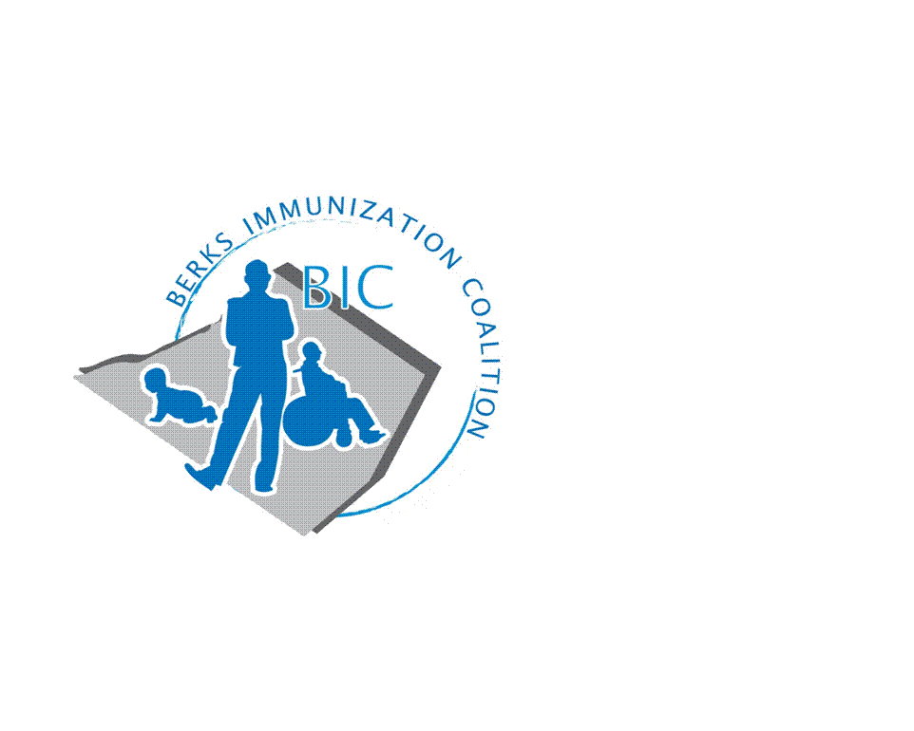
BERKS IMMUNIZATION COALITION
GENERAL MEETING MINUTES
January 18, 2022

Attendees: Nicole Berger, Cindy Hinsey, Jennifer Fulton, Sarah Kinsey, Jes Long, Tracy Ravert, Lisa Reiter, Tracy Scheirer, Tara Smith
OLD BUSINESS
  - Approval of Minutes
  - Treasury Report -Balance $9559.76
    - Promotional items purchased over summer
  - DOH Report –
- NEW BUSINESS
  - DOH replacement- no word at this time who is going to replace Rose
  - COVID vaccine
    - TH at Home and Area Office of Aging- Lisa is giving COVID vaccine to homebound patients through the Homebound COVID vaccine program.
      - $7,000 grant from United Way for any homebound person.
      - Pfizer COVID vaccine
    - Sarah K.-There have been problems with vaccine record not being recorded in SIIS
      - IQuip meeting with VFC
    - Tracy S. is volunteering at the Medicine Shoppe in Shillington giving COVID vaccine.
      - Plenty of vaccine, not enough people to give vaccine
    - Booster- Large community booster plans: vaccine to be available in pharmacies and doctor’s offices
      - Flu and booster able to be administered together
  - PAIP Grant
    - Kayla- PAIP received grant opportunity: $100K project funding is for FY now and extended past July 30th
      - Grant completed, documents have not been signed
      - Part time (15-25 hrs/wk) job description to cover BIC marketing and communications. Looking for new grad with a public health degree
      - Tracy S.- Medicine Shoppe is looking to hire a nurse to administer COVID vaccine, is this an appropriate way to utilize some of the grant money?
      - PAIP to manage individual
      - Work together with Schuylkill and Montgomery
  - Educational Outreach Program
    - Sarah K.- Lancaster already approved. Coordination of effort with Lancaster, share ideas, they are actively engaged.
      - Hurdle: building trust- outreach into community
      - In need of materials that do not have government agencies on them
    - Reading Royals
      - February 19, 2022
      - Set up at 1430, game starts at 1600
    - Fightin Phils
      - Tracy R. will reach out to Joe at Fightin Phils
      - Swag giveaway
    - HPV
      - Tracy S. partnered with Communications at Alvernia
        - Someone you love presentation on campus
        - Discussion about HPV after
        - Shot for a shot: bucket of money
          - Money donated to Yellow Umbrella
      - Increase in 1 in 60 cancer rates for men. Need to increase HPV vaccination rates for men
    - Redner’s
      - Vaccine reminder article
  - Immunization conference June 14, 2022
  - Meeting Dates – March 29, June 28, September 27

Respectfully submitted,
Nicole
Nicole Berger, RN
Berks Immunization Coalition Secretary

