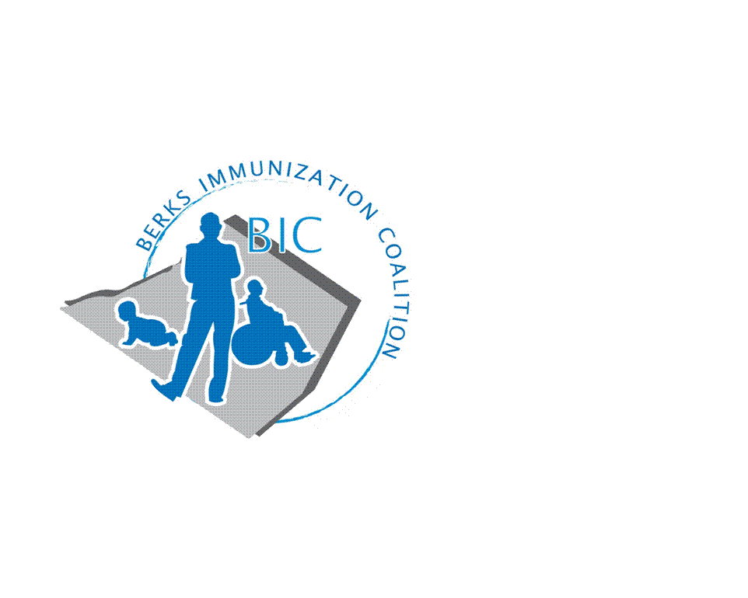
BERKS IMMUNIZATION COALITION
GENERAL MEETING MINUTES
January 24, 2019

Attendees: Nicole Berger, Andy Krug, Maria Melendez, Tracy Ravert, Tracy Scheirer, Tara Smith, John Vogel, Karen Wang
- OLD BUSINESS
  - Approval of Minutes from 9-29-20 – Tracy Scheirer and John Vogel
  - Treasury Report – Tracy Ravert has consented to serve as Treasurer. Tracy S. and Tracy R. will meet to add signators on account at Diamond Credit Union. Current balance- $10,476.69
  - DOH Report – no rep present but significant focus is on COVID and contact tracing at present.
  - Twitter account @BerksCoalition. Encourage sharing and following.
- NEW BUSINESS
  - COVID vaccine sign ups shared by Tracy S. at PSH and Tower for category 1A personnel. Discussion about difference between EUA for Moderna and Pfizer vaccines. John Vogel states that many seniors are asking questions about getting flu vaccine and COVID vaccine.
    - Berks Community Health Center is looking for volunteers.
    - Tracy S. is sharing information at Alvernia University among students and faculty. PA has waived licensure requirement for students so that they are able to vaccinate.
    - Follow up with Rose Grill at DOH about Vaccine Finder provider map. How is this working?
  - Planning Activities- Discussion about the time needed to do any activity planning for 2021 amid unknowns related to COVID. Conclusion- reach out to Eric White at Redners Markets to place a graphic and/or story in their marketing materials as we have done in the past. Tracy S. will contact Eric about this.
    - We will look for information about Fightin Phils games for summer- outside activity.
  - Legislative Committee
    - Contact your legislators www.legis.state.pa.us/cfdocs/legis/home/find/cfm
  - 2021 remaining Meeting Dates
    - March 30, June 29, September 28.

Respectfully submitted, Tracy Scheirer BIC Chair

