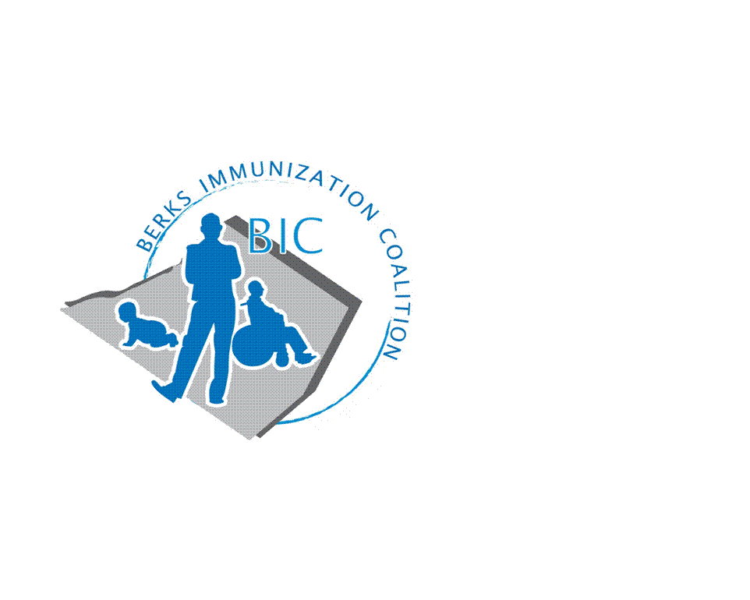
BERKS IMMUNIZATION COALITION
GENERAL MEETING MINUTES
January 21, 2020

Attendees: Nicole Berger, Rose Grill, Kimberly Meglathery, Tracy Ravert, Tracy Schierer, Tara Smith, Larry Sundberg, Beth Till, Dennis Udicious, Kim Young
- OLD BUSINESS
  - Approval of Minutes – Tracy Ravert and Nicole Berger
  - Treasury Report – $2978.69.
    - A reimbursement of $800 was paid to Tracy Schierer for payment of Fightin Phils table ($500) and BIC refreshment sponsorship for Christine Baize appearance at the Miller Center ($300). Tracy still needs reimbursement for purchase of Plinko game for outreach activities.
    - Tracy Ravert has volunteered to be BIC’s new Treasurer. This was approved by unanimous vote of meeting attendees.
    - $8000 will be deposited into the treasury from the grant awarded to BIC for the PAIC.
    - An audit of treasury funds will be conducted annually in January.
  - DOH Report – As reported by Rose Grill, sporadic pertussis, varicella and mumps in Berks County. No measles to date.
  - Bus logo – BIC campaign was not completed as PAIC conducted a bus campaign and included Berks County in its distribution. Be alert for buses!
  - New Twitter Account - @BerksCoalition. Please share.
    - Other social media suggested – Instagram, Tic Toc, Snapchat.
    - BIC has a Face Book page, please send friend request

- NEW BUSINESS
  - Planning Activities
    - Teen Video Challenge – Work with Middle and High School nurses, art and technology teachers. Create a 30 second teen focused video message about the importance of vaccinations in this population. Committee will create rules, prizes and due dates. Will focus on Tdap/HPV/Meningococcal. Projects will be submitted to BIC for judging and then posted on You Tube and the PAIC website. Deadline: Fall 2020
      - It was suggested by Larry to give a prize to the winning school for tech supplies in addition to the winning student.
      - Beth Till mentioned New Jersey’s project “Protect me with 3 +” campaign as a guide. More information at www.protectmewith3.com
      - Committee Members – Tracy Schierer, Nicole Berger, Beth Till, Tracy Ravert and Rose Grill
    - Reading Royals – BIC will have a display table at the February 22 Reading Royals hockey game. Thank you, Cindy Hinsey, for spearheading this project. Volunteers – Larry Sundberg, Kim Meglathery, Beth Till, Tracy Ravert and Cindy Hinsey. Please arrive at the loading dock entrance of the arena on the Penn Street side at 5:30 pm for directions to your display area.
    - Immunization Awareness Day at the Fightin Phils - Joe Bilak has been contacted for a date in August. We will announce date at the March meeting and ask for volunteers.
  - PAIC – Save the date PIC 2020 – PAIC meeting June 17, Immunization Conference June 18. It will be held at the Harrisburg Hilton.
  - Legislative Committee
    - Contact your legislators with vaccine issues – www.legis.state.pa.us/cfdocs/legis/home/find.cfm
  - Other items of discussion
    - Please contact Tracy Schierer with requests for community speaking engagements
    - Reading Eagle contact, Matt Majory, is no longer employed at the paper. Does anyone have a contact that can be utilized for BIC exposure?
    - Dennis and Tara with get new, unbranded educational information to Tracy S. for BIC outreach activities.
  - Other Meeting Dates
    - March 31, June 30, September 29.

Respectfully submitted,
Rose
Rosemary Grill, RN
Berks Immunization Coalition Secretary

