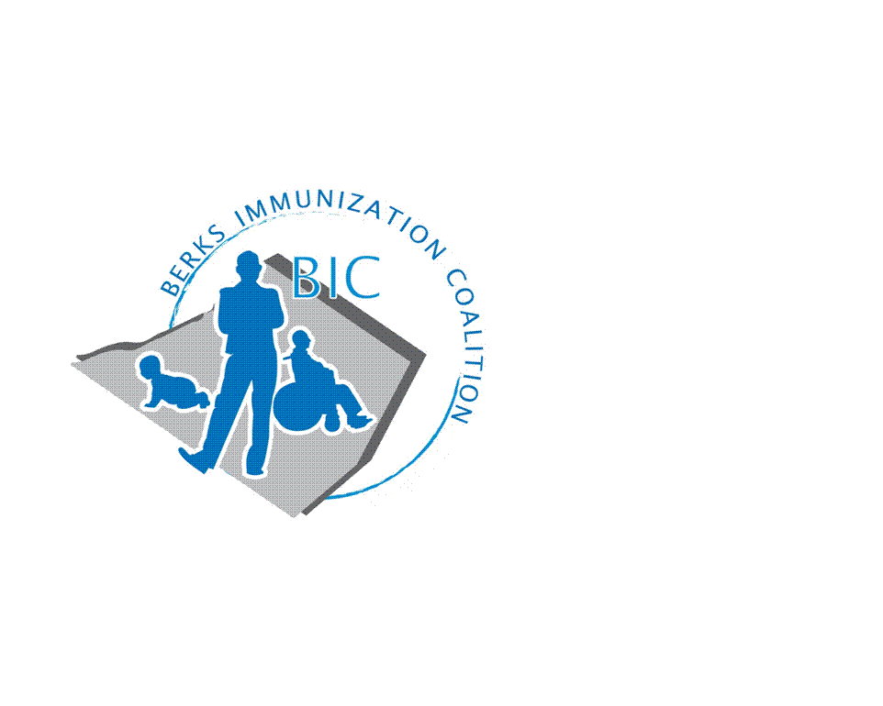
BERKS IMMUNIZATION COALITION
GENERAL MEETING MINUTES 1-23-18
Attendees: Harryl Allen, Rose Grill, Cindy Hinsey, Joyce Jost, Stacey Lattanze, Maria Melendez, Samantha Pierpoint, Tracy Ravert, Tracy Scheirer, Stefanie Schmitz, Tara Smith, Marisa Swisher

- OLD BUSINESS
  - Approval of Minutes from 9-26-17 meeting – Approved by Rose and Stacey
  - Treasury Report - $4619.64
  - DOH Report – Rose reported on vaccine preventable diseases in Berks County – local school outbreak in November/December 2017. Clinics will remain bi-monthly at the Berks County State Health Center.
  - #UDontgetit campaign materials for Bus Campaign – Materials have been updated by Saison via Amy Wishner, PAAAP. Harryl will email to Tracy R, Tracy S and Rose.
  - Senior Expo – October 24 ,2017 at Double Tree by Hilton in Reading. Well attended. Tracy S. and Duane represented BIC and educated regarding adult/senior vaccine recommendations. Unsure if BIC will participate next year due to cost.

- NEW BUSINESS
  - Planning Activities
    - Membership and recruitment committee needed – please consider volunteering
    - Plans for 2018 focus
      - It was decided by the group that the bus campaign kick-off would be in September/October 2018. New materials for #UDontgetit will be sent to committee by Harryl. Barta uses Direct Media and they will be able to convert the materials to the proper format for the buses. QR Codes will be added in to track number of people viewing the posters.
      - Fightin’s dates – Rose will contact Eric White for dates in August. Suggested tying it in with an article in the Reading Eagle and the possibility of advertising the event in other media outlets. It was suggested to place on the Reading SD website. Tracy R will research.
      - Medical Assistant Program – The group expressed a need for immunization training for MA’s in Berks County. Harryl will set up conference call with Amy Wishner, Samantha Pierpoint, Marisa Swisher, and Rose Grill. He will also contact Veronica Alvarez at Philadelphia Health Department who has done a program on the past. Anyone else interested in participating in this committee, please contact Harryl or Rose so you can be included in the call.
      - Tara reported on the new American Cancer Society Campaign – HPV Cancer Free. External launch is June 8, 2018. The goal is to increase HPV rate and to eliminate gender and geographic disparities. Contact with the ACS is Erin Mascal. Packet of information given to Tracy S for review. Suggested using these materials as part of education at the Fightin’s game in August which is National Immunization Awareness Month.
  - PAIC
    - Harryl secured a grant for $100,000/year for 5 years. PAAP will act as Fiscal Agent.
    - PAAAP does not have enough funding to take on PAIC full time. Samantha is currently updating the PAIC website, Facebook and Twitter pages. Information will be in a universal format so all local coalitions will be able to access. The calendar has been updated and Samantha is working on mobile phone format.
    - PAIC Meeting – August 15 at the Harrisburg Hilton – Please send any ideas for the meeting to Amy Wishner or Gail Wright.
  - Legislative Committee
    - Contact your legislators with vaccine issues. www.legis.state.pa.us/cfdocs/legis/home/find.cfm.
  - Other Discussion
    - Ms. Aliyah Muhammad from the Association of Immunization Managers (AIM) requested that the Pennsylvania Immunization Program present during their HPV Call-to-Action Webinar. Specifically, AIM wanted to feature Pennsylvania’s efforts to support coalition-based immunization education campaigns in Chapter 2, “Engaging Teens Directly “of their Adolescent Immunization Resource Guide. To promote the release of Chapter 2 and close out the final HPV Call-to-Action webinar of 2017, AIM extended an invitation to Pennsylvania to present our program’s highlighted activities in the Chapter. The webinar occurred on Wednesday, December 13th at 2PM ET. Harryl Allen, Public Health Administrator, Division of Immunizations, Pennsylvania Department of Health, presented the strategies, successes, and lessons learned from the #UDONTGETIT project. This presentation will be featured in the 2018 AIM Adolescent Immunization Resource Guide, please use the following link found review Chapter 2 of the guide https://aim.site-ym.com/page/AdRG_CHAPTER2
    - Discussion around flu – Harryl will send out latest flu report from the CDC. H3N1 part of vaccine is 10% effective. This is the dominating circulating strain.
    - 40% of adults obtain vaccine from their pharmacy. Pharmacies report in Statewide Immunization Information System (SIIS).
    - www.vaccinefinder.org. Help in locating vaccination sites. Overseen by the CDC.
  - Future Meeting Dates
    - March 13, June 27, September 25. All meetings are held at The Reading Hospital R-Ground Conference Center at 8:00 am.

Respectfully submitted,
Rosemary Grill, RN
Berks Immunization Coalition Secretary

