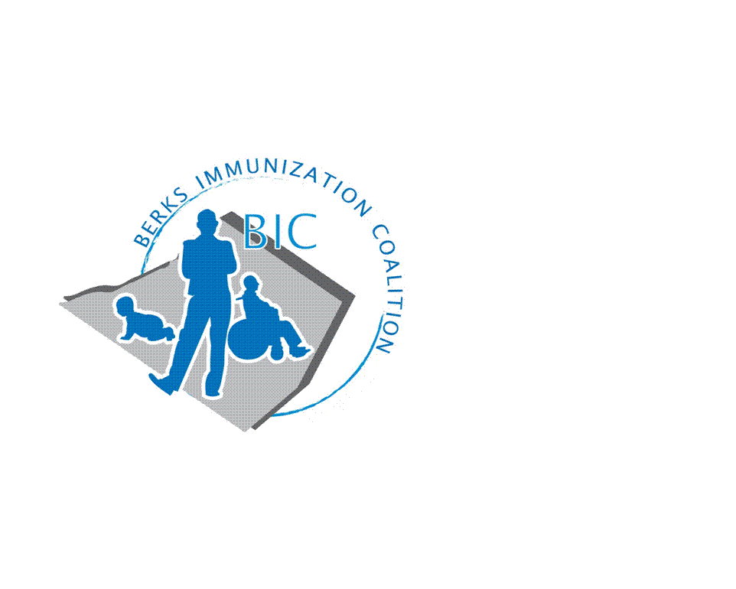
BERKS IMMUNIZATION COALITION
GENERAL MEETING MINUTES
January 24, 2019

Attendees: Rosemary Grill, Cindy Hinsey, Maria Melendez, Tracy Ravert, Tracy Scheirer, Tara Smith, Kim Young
Welcome new BIC Member: Larry Sundberg
- OLD BUSINESS
  - Approval of Minutes – Tracy Scheirer and Rose Grill
  - Treasury Report – Marisa Swisher has handed over Treasurer position to Tara Livinghouse. Welcome Tara. No changes from last quarter.
  - DOH Report – Vaccine preventable diseases are reportable to local State Health Centers. As reported by Rose, there are sporadic cases of varicella, pertussis and mumps in Berks County.
  - Chairperson, Tracy Scheirer spoke to the Greater Reading World Affairs Council about Vaccines and Global Health on January 16. She has also been asked to speak at Adamstown and Lebanon Libraries.
  - BIC members, Tracy Scheirer, Tracy Ravert, Maria Melendez, Beth Till and Rose Grill participated in Immunization Awareness Day at the Fightin Phils this past August. Eric White provided us with games which drew many children and parents to our display. Prizes included crayons and lip balm. Tracy S. suggested using BIC funds to purchase a Plinko game to use at future events, the group approved the purchase.

- NEW BUSINESS
  - Planning Activities
    - Bus Campaign – UDontGetIt - we have reached a standstill due to type of file needed. We need a vector file. Tracy will check with the design instructor at Alvernia to see if they can assist us.
    - New Funding – Harryl Allen awarded BIC a $5000 grant to use for a project. Thank you Harryl!!! Several ideas were suggested
      - Immunization Update Dinner
      - HPV speaker at a local high school or college
      - Someone You Love film being shown at the local High Schools, possibly during Cervical CA Awareness Month in January; Accent TV at Tower Health; in-house programing at St. Joseph; Berks Community Health Centers; and Family Health Care Center
        - The group decided on two possible projects
          - Tracy Ravert will query school nurses to see if showing the film at local high schools would be a viable option. The film does come with Spanish subtitles. Maria Melendez will explore the option for Berks Community Health Center, Cindy Hinsey for St. Joseph, and Kim Young for FHCC.
          - Tracy Scheirer and Rose Grill will explore the option of having Christine Baize, cervical cancer survivor, speak at Alvernia University. Target date – October 2019. Tara Smith will put us in touch with Trish Bolton, Merck University Account Rep. Trish has some great insights to share from her past experiences dealing with colleges and has some ideas and resources to help maximize pull through at the college/university level.
  - PAIC
    - The PAIC general meeting will be held on June 26 at the Harrisburg Hilton with the Pennsylvania Immunization Conference the following day, June 27. Please refer to the PAIC website for more information www.immunizepa.org.
  - Legislative Committee
    - Contact you legislators with vaccine issues.
      - www.legis.state.pa.us/cfdocs/legis/home/find/cfm
  - Other Meeting Dates
    - March 26 – Room 6
    - June 26 – Room 13 – PAIC Meeting in the afternoon, Harrisburg Hilton Hotel
    - September 17 – Room 13

Respectfully submitted,
Rose
Rosemary Grill, RN
Berks Immunization Coalition Secretary

