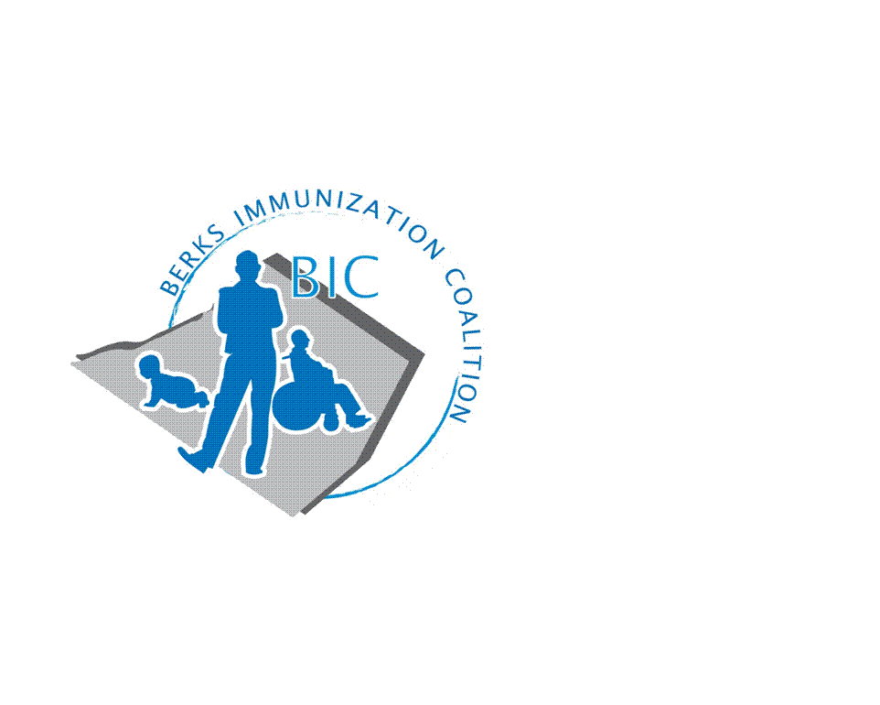
BERKS IMMUNIZATION COALITION
GENERAL MEETING MINUTES
January 31, 2023

Attendees: Jes Long, Andy Krug, Tracy Scheirer, Lisa Reiter, Tracy Ravert, Tara Smith, Rachel Hahn, Colette Oliveira, Jennifer Lago, Kim Meglathery, Jim Niland (subbing for Sarah Kinsey)
OLD BUSINESS
  - Approval of Minutes – postponed – will send out September minutes with today’s minutes
  - Coalition Treasury Report - Balance $9,559.76
    - No new changes for treasury report
  - Berks Immunization Coalition social media
    - Twitter account still open – not being used as much anymore
    - New BIC Facebook page – link to page sent in meeting chat
      - Need more likes/follows
- NEW BUSINESS
  - Continuing grant- now in year 2. Lots of ideas, need more people to help execute
    - Rachel – Programmatic Updates
      - Outright Campaign
        - Started December 13th – running through March 13th
        - Using ads that mention “we do little things for our kids everyday, getting vaccinated should be one of them”
          - Video and still image ads
        - Running on Facebook/Instagram and ~1,800 different websites
        - Outright gives biweekly metrics including video completions, ad clicks, picture/video views, etc.
      - Campaign with Barta Buses
        - Using ads from Outright
        - Bus shelters, bus tails (backs of buses), and super kings (under side windows)
        - Not up and running yet – will give update when officially started
      - Shillington Medicine Shoppe
        - Rachel will contact Dipak for another pop-up clinic partnership
        - Main goal is to vaccinate the underinsured/uninsured
  - Lisa Reiter – update on Tower Health
    - Clinic closed this year due to several factors
    - No other standing clinics (outside providers’ offices) besides Reading SD school-based clinic
    - Need a place to house the clinic within the Tower Health system
      - If they were to reopen – would need more staff and at least one bilingual nurse
  - 2023 Event Ideas
    - Possibly hold a dinner for the coalition
      - Ideas for speakers?
      - Need assistance in planning this dinner
        - Tracy Ravert volunteered to help with planning
      - Best way to draw people in is to offer CE credits
        - Tracy S. can put Tracy R. in contact with people who organize CE offerings
        - Rachel might know of someone at PAAAP office who can organize CE application process for other professions (i.e., pharmacists)
  - Educational Outreach Program
    - February 18th – Reading Royals game
      - Game starts at 4pm – will likely set up table around 2pm
      - Holding a vaccine education table
        - Giveaway items/games/educational handouts
      - Tracy R. and Tracy S. to attend
        - Need more volunteers from coalition
    - Planning to attend Reading Phils game again in the summer
      - No date picked yet
  - Legislation Updates
    - Any state-level proposals related to vaccines?
    - Proposal to lift COVID emergency status in May
      - Pharmacy reps on call
        - Jim Niland (Sanofi) – no specifics other than proposed date of May 11th to lift COVID emergency
      - Significant bump in cost of the vaccine
        - Colette Oliveira (Pfizer) – no official changes yet in cost of vaccine
          - Still being paid for by federal government
    - Update on VFC Adult Program – Jes Long (GSK)
      - Medicare Part D now covering Tdap, Shingles vaccines for adults
        - Part of Inflation Reduction Act
  - Meeting Dates – moving to bimonthly meetings
      - Meeting on last Tuesday of every other month at 8am
        - March, May, July, September, November
      - Need new secretary for coalition
        - Asking anyone from coalition to volunteer for the role

Minutes Completed By:
Rachel Hahn, MPH
Immunization Coalition Coordinator

