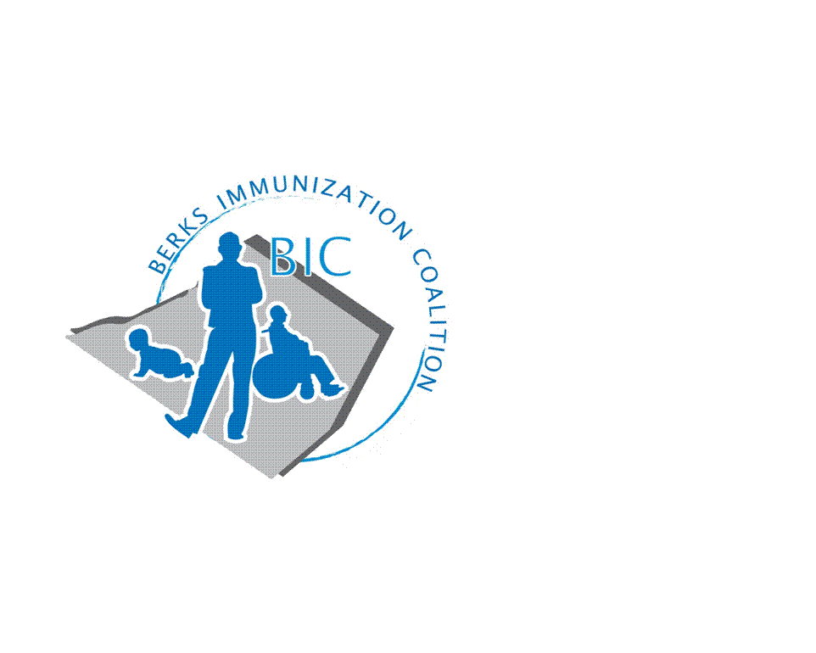
BERKS IMMUNIZATION COALITION
GENERAL MEETING MINUTES
Attendees: Brian Bergston, Rose Grill, Cindy Hinsey, Joyce Jost, Cindy Kaszmetskie, Maria Melendez, Samantha Pierpoint, Cherie Raub, Tracy Scheirer

- OLD BUSINESS
  - Minutes from 1-23-18 meeting approved by Rose and seconded by Maria Melendez
  - Treasury Report - $4619.64
  - DOH Report – VPD Report - Sporadic cases of pertussis. No outbreaks in Berks
  - Bus Campaign – Launch for fall is still in place. Will use UDontGetIt materials. Committee: Tracy Ravert and Tracy Scheirer

- NEW BUSINESS
  - Planning Activities
    - Fightin’s Date - Sunday 8/12/18 5:05 game time. Redner’s Markets will again provide BIC with a table during National Immunization Awareness Month. We will need a total of 4 volunteers for two shifts to cover set-up and tear-down. Please let Rose know your interest in assisting with this yearly event. Eric White will provide us with promotional items for handouts, THANKS ERIC!! It was suggested that we have a game, such as a spin wheel, to draw people to the table. Please send your ideas or bring them to the June meeting.
      - Tracy Scheirer will contact Matt Nojori at the Reading Eagle for coverage of the event
  - PAIC website
    - PAIC Meeting will be held August 15, in the afternoon and the PA Immunization Conference will be on August 16, both at the Harrisburg Hilton. Please check website for more information https://www.immunizepa.org
    - PAIC is now posting coalition minutes on their website, thanks Samantha!
    - UDontGetIt materials are available on the website
    - Teen Health Week – Twitter Chat 3-19-18 at 12 PM – Please see attachment
  - Community event presented by Berks Community Health Center at the RACC Miller Center, 4 North 2nd Street, Reading.
    - It’s not about sex, It’s about cancer. It’s a Talk About the HPV Vaccine. Cervical cancer survivor, Christine Baze, guest speaker. Christine is an activist, survivor and one or the five women featured in the file “Someone You Love.” Please see attachment.
      - Thursday, April 5, 2018. Doors open at 6:00 pm
      - Tracy will contact Debra Hartranft regarding a BIC table at the event
  - Legislative Committee
    - Contact your legislators with vaccine issues
      - http://www.legis.state.pa.us/cfdocs/legis/home/findyourlegislator/index.cfm
  - Medical Assistant Training Program – Cindy Hinsey inquired about status of MA program. Currently, there is no progress. Group agreed that there is a need for vaccination training not only with MA’s, but also RN’s and LPN’s. Rose will obtain program used in Philadelphia from Amy Wishner and Harryl Allen. Cindy Kaszmetskie and Joyce Jost have agreed to also do research into how we can offer this service to the medical community.
- Future Meetings
  - June 27, 2018
  - September 25, 2018

Respectfully submitted,
Rose
Rosemary Grill, RN
Berks Immunization Coalition Secretary

