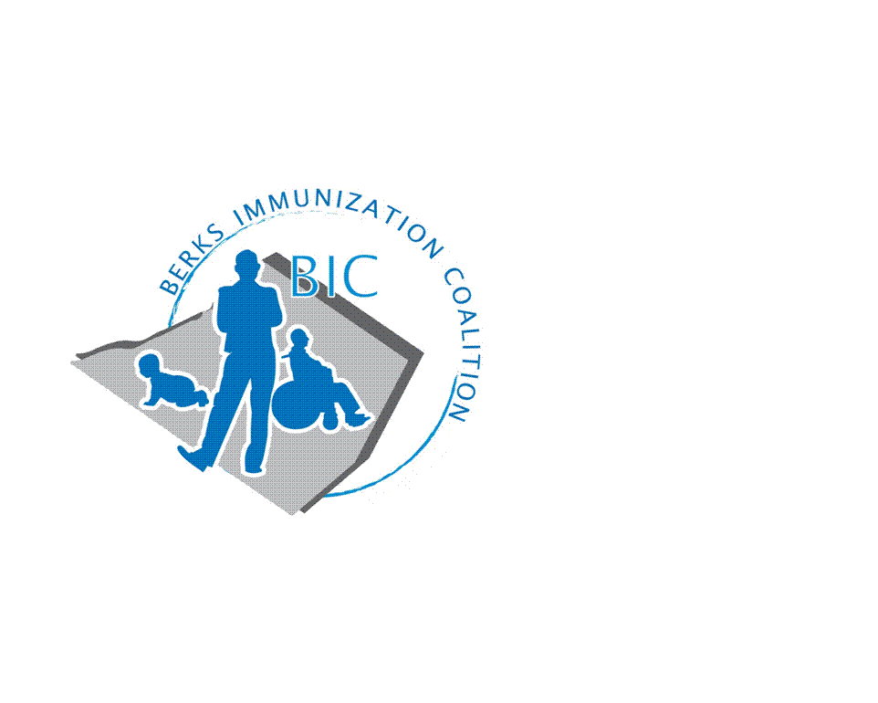
BERKS IMMUNIZATION COALITION
GENERAL MEETING MINUTES
March 29, 2022

Attendees: Nicole Berger, Sarah Kinsey, Jes Long, Tracy Scheirer, Tara Smith, Sarah Kinsey, Andy Krug, Anne Fisher, Darin Walls, Marnita Hartline, Kayla Knock, Maria Alicea, Rachel Hahn
OLD BUSINESS
  - Approval of Minutes – approved
  - Treasury Report -Balance $9559.76 at Diamond Credit Union
    - Promotional items purchased over summer
  - DOH Report –
- NEW BUSINESS
  - DOH replacement- no word at this time who is going to replace Rose, Peggy Glass visiting practices
  - COVID vaccine
    - Pfizer and Moderna are recommending a 4th dose of vaccine
  - Educational Outreach Program
    - Reading Royals
      - February 19, 2022
      - Successful event- Tracy Scheirer, Tracy Ravert, Cindy Hinsey volunteered
      - Touch is Essential display at Reading Royals game- display and biography of people who had roles in the pandemic, honored essential workers. We were stationed across from this and it drew visitors to table.
    - Fightin Phils
      - Tracy R. reached out to Joe at Fightin Phils
      - BIC does have a contract for 1 game, waiting for list of games that are family oriented.
        - 200 tickets GA tickets to be given away
        - Game will be in August
        - Radio spot for 3rd inning to discuss vaccination issues
        - Will consider ordering a popup cover or tent- no objection to spending money
        - Promotional items- crayons, water bottles, string bags

    - Billboards
      - Rachel- 18 billboards in Berks County, some are in Spanish closer to inner city Reading, some billboards will switch digitally. Message I vaxxed my kid, there is unity in immunity. Up for 4-8 weeks. Will reevaluate- Kayla, first round doesn’t have a QR code but they do have a URL
        - Will consider QR code for next round of campaign
      - Bus Campaign with BARTA Buses with same images and messages- windows, tails, interior April for about 12 weeks
      - Mobile GeoFencing will bring up a digital ad on mobile device of person near the ad
      - BIC logo included in the images
    - Outreach and PAIC Website
      - Vaccine Clinic flyer- different vaccine clinics are listed
      - Rachel is the Point of Contact and listed on website to get new attendees
        - Reached out to school nurses in Berks County
        - Waiting for more responses
        - Reached out to community resources- Reading YMCA- BJ- do have people tabling in their lobby for 6 weeks at a time, will be added to coalition list.
    - Grant proposal included reaching out to community churches, hair dressers and barbers for getting info out to the community
      - Increase vaccine rates by one person at a time may be the way to go
      - What other ways could we promote vaccination?
    - Redner’s
      - Vaccine reminder article- Tracy S. to create.
      - Redners has given permission for article that will be edited by nutritionist
  - Immunization conference June 14, 2022
    - Kayla will circle back when registration is open
    - Day before conference hoping to get all coalitions together for conference
    - Tracy Scheirer will be there
  - Andy Krug- social media- starting a social media campaign and get info from PAIC, Men B action project, importance of getting adolescents caught up on vaccinations, PAAP, partnering with Berks Community Health Center, AAC, HPV, Tdap, flood local social media
    - Kayla is working on vaccination rates data for Berks County
    - PA SIIS will be updating platform in the next year or two
    - Getting legislators involved to have connection between EHR and SIIS
  - Jes Long- Avalere Health- missed doses of vaccines on a national level approx. 8.8 million fewer doses of adolescent vaccinations
  - Nicole- creating PDSA to improve vaccination rates amongst 11-13 year olds at AAC focusing on procedure
  - Maria- implement vaccines to WCV, MA will inform parent what vaccines they will be getting today, then provider will come into office and tell them what vaccines they must be given. Catch up will be required to be given prior to the beginning of the school year.
  - Tracy- community work- two other projects: Lisa Reiter- director of TH at Home Vaccine program, did get a small grant to continue their work. Long established VFC site- Tracy discussed idea with Kayla and Pat and wants to ensure that money given to TH only to be used for the vaccination program
  - Kayla- tomorrow 3.30.22 vaccinate your family. Webinar- https://us06web.zoom.us/webinar/register/WN_3uwGKiCQRiatqFQglnamXg
- Meeting Dates – June 28, September 27

Respectfully submitted,
Nicole
Nicole Berger, RN
Berks Immunization Coalition Secretary

