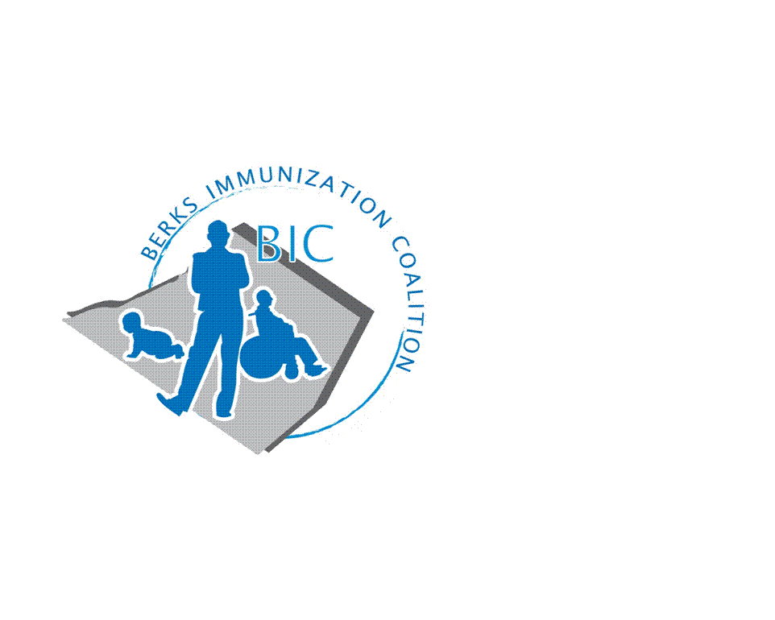
BERKS IMMUNIZATION COALITION
GENERAL MEETING MINUTES
June 26, 2019

Attendees: Raine Fussner, Rose Grill, Cindy Hinsey, Kim Moleski, Tracy Ravert, Tracy Scheirer, Kim Young, Nicole Berger, Kimberly Meglathery
- OLD BUSINESS
  - Approval of Minutes – Tracy Scheirer and Rose Grill
  - Treasury Report – $3,776.69.
    - Reimbursement to Tracy Scheirer for BCHC refreshments still pending.
    - Received $8000 grant for PAIC. How will the money be disbursed? Tracy will speak with Harryl Allen to determine distribution of funds.
  - DOH Report – No VPD outbreaks in Berks

- NEW BUSINESS
  - Planning Activities
    - Bus Campaign-Committee, Tracy Ravert and Tracy Scheirer. Discussion on #UDontGetIt graphics. It was decided that the graphics are too dark and only focuses on adolescents. With the measles outbreak it was decided that a more general message would be appropriate. The group agreed that something simple and “eye catching” was needed. A suggestion “DON’T WAIT VACCINATE” with the different vaccines listed was discussed. The projected roll out date will be this fall.
    - August 4th – Fightin Phils game. Redner’s is no longer able to sponsor a table for BIC. Tracy R. contacted Joe Bialik, General Manager to reserve a table. Cost $500. Cost includes a radio spot for Tracy S. to discuss immunizations. Gates open at 3:00 pm and there is Harry Potter theme.
      - Volunteers this year include: Tracy Ravert, Tracy Scheirer, Nicole Berger, Beth Till and family, Kim Meglathery, Kim Young. If anyone else is interested, please let Rose know. Shifts are 2:30-4:30 (set-up) and 4:30-6:30 (tear-down).
      - Tracy S. requested permission to purchase a Plinko game for $188. Group agreed.
  - PAIC
    - Annual Meeting – June 26, 2019
    - PA Immunization Conference – June 27, 2019
  - Legislative Committee
    - Judy Schwank introduced a bill supporting immunizations. A press conference was held at the Reading Hospital on May 17th. Tracy Ravert and Eve Kimball were in attendance.
  - New Twitter Account - @BerksCoalition. Please share
  - Other Meeting Dates
    - Next meeting September 17 (Tuesday) Room 13

Respectfully submitted,
Rose
Rosemary Grill, RN
Berks Immunization Coalition Secretary

