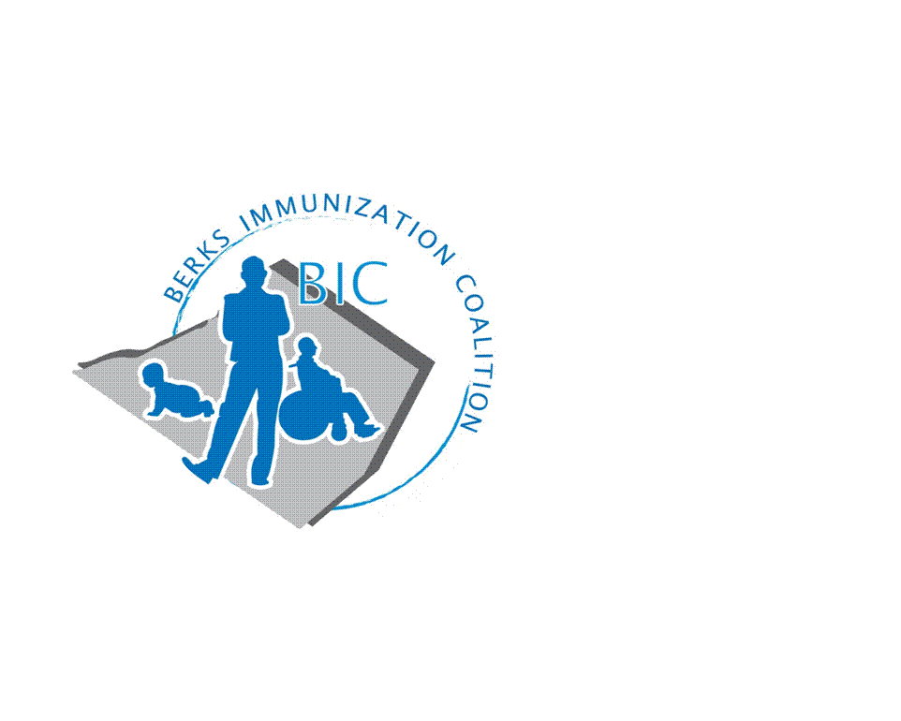
BERKS IMMUNIZATION COALITION
GENERAL MEETING MINUTES
June 27, 2017
Attendees: Rose Grill, Cindy Hinsey, Maria Melendez, Tracy Ravert, Tracy Scheirer, Tara Smith, Marisa Swisher, Beth Till, Eric White, Kim Young, David Fox, Erin Moskel
- OLD BUSINESS
  - Approval of Minutes – approved by Tracy S. and Tracy R.
  - Treasury Report – Reported by Marisa – unchanged - $4619.64. Marisa will be relinquishing the Treasurer roll to Tara Livinghouse. Good luck on your new adventure!!
  - DOH Report – Rose reported sporadic cases of pertussis and varicella
  - HPV speaker – Someone You Love with Christine Baze – sponsored by Berks Community Health Center. Approximately 125 in attendance.
    - BIC representation was present – supported refreshments for the evert ($300)
  - Bus Campaign – launch for fall – on hold – Tracy R. will check with Harryl Allen regarding possible funding

- NEW BUSINESS
  - Planning Activities
    - Fightin’s Date
      - Sunday 8/12/18 game time 5:05
      - Committee received approval from the group to use $300-$400 to purchase give away items. The group liked the idea of nylon back packs. Eric supplied games to draw attendees to our table.
      - Volunteers – Rose, Tracy S., Tracy R., Maria. All are welcome! If anyone else would like to assist, the shifts are 3:00-5:00 (set-up) and 5:00 – 6:00 (clean up). Gates open to the public at 3:30.
  - PAIC
    - PAIC Annual Meeting – August 15th in Harrisburg. PA Immunization Conference is August 16th. Registration is still open https://www.immunizepa.org/
    - BIC Meeting Minutes are posted on the PAIC website.
  - American Cancer Society HPV Campaign
    - Erica Moskel from ACS discussed the launching of Mission: HPV Cancer Free, a public health campaign to eliminate vaccine-preventable HPV cancers. Please see attached flyer. ACS is partnering with Tower Health – Reading Hospital to promote the project in November. Rose and Tracy S. have been invited as BIC representatives to attend the Round Table Discussion at Reading Hospital on July 12 hosted by Dr. Iman Haroun, genetic counselor at McGlinn Cancer institute of Reading Hospital
  - Legislative Committee
    - Contact your legislators with vaccine issues www.legis.state.pa.us/cfdocs/legis/home/fine.cfm
  - Meeting Dates – NEXT MEETING SEPTEMBER 25, 2018 AT 8:00 AM

- OTHER DISCUSSION
  - Reading School District – VFC clinic has moved location to the Reading High School. Five Back to School Clinics will be held in August. Hours will be listed on the RSD website https://www.readingsd.org/
  - Berks Community Health Center Urgent Care will hold evening walk-in clinics for immunizations, Monday-Thursday from 4 PM – 9 PM. Criteria is that client needs to already by their patient or become their patient.
  - Tracy S. discussed bringing her senior nursing class to the next meeting as part of their Community Health experience. The group was very enthusiastic to have them attend.
  - There was discussion surrounding the increasing anti-vax voice becoming more vocal and effecting legislation. Please contact your representatives. If you are unsure who that is you may find at www.legis.state.pa.us/cfdocs/legis/home/fine.cfm. Tracy will contact Judy Schwank.
Respectfully submitted,
Rose
Rosemary Grill, RN
Berks Immunization Coalition Secretary

