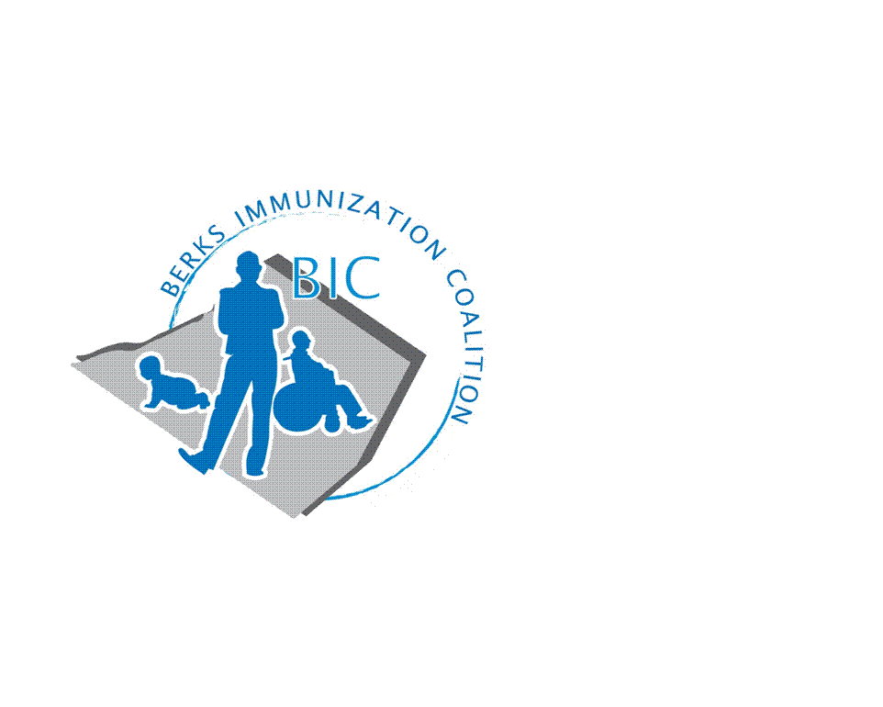
BERKS IMMUNIZATION COALITION
GENERAL MEETING MINUTES
June 28, 2022

Attendees: Nicole Berger, Tracy Scheirer, Lisa Reiter, Sarah Kinsey, Tracy Ravert, Lucinda Hinsey, Rachel Hahn, Andy Krug, Jes long, Kayla Knock, Maria Alicea, Thomas Dumas, Stephanie Mihailescu, Peggy Glass
OLD BUSINESS
  - Approval of Minutes – approved Tracy Ravert, Lisa Reiter
  - Treasury Report -Balance $9559.76 at Diamond Credit Union
    - No changes, independent of funds from grant
    - Goal to change signer of bank account this summer
  - Tracy is following Twitter, no other social media accounts at this time
  - DOH Report – no report at this time. Per Tracy Ravert, Peggy Glass is performing site visits
  - Community health organizers- there is someone assigned to Berks: Jayla Mcfadin info is posted on DOH website
  - Rachel is organizing contact list- did connect with YMCA location, she will reach out to all YMCA locations for tabling or events, does have a meeting with BJ from Reading YMCA
  - Contacts: 5 messages were delivered back to Tracy S. as undeliverable. Will need to remove the people from the active list to keep up to date- Nicole and Rachel to address
  - Tracy wants to get the calendar organized for 23
- NEW BUSINESS
  - Grant from PAIP- activities to focus on
    - Kayla has a lot of ideas for vaccination and pop-up clinics
      - Would like to utilize money for more in-person events.
        - find a pharmacy in the area to store and clinician to administer vaccines, for peds would need clinicians from pediatric office to volunteer.
          - Peggy- suggests easier to set up adult clinics. Clinic for tdap for the adults (317 funded- is very limited until new grant funding in October).
            - Kayla- Grant is COVID focused for boosters and 1st dose COVID vax but she will see if ok to use money for vaccines across the lifespan
    - Medical reserve core- regional offices- Matt Kratz, Brittney Fulton-
  - Educational Outreach Program
    - Fightin Phils
      - Tracy R. reached out to Joe at Fightin Phils
      - Game scheduled for August 7th
        - 200 tickets GA tickets to be given away
        - Radio spot for 3rd inning to discuss vaccination issues
        - Tracy R.- RASD students music videos can be broadcasted during game.
        - Promotional items- crayons, water bottles, string bags
      - Tracy will send out list for volunteers-
        - 3-5p
        - 5-7p
    - Tracy S. a focus project for 2023, involving adolescents, create a plan for what we can do in the spring semester, art and tv studio teachers for multimedia contest
    - Tracy S. has been invited as a member of Alvernia- Berks Fall Coalition Event Fair on Sept 22. Nursing is a large part of health sciences at Alvernia
      - tabling event there- at a minimum would like to present educational materials but it would be great if we could administer vaccines at the event- located at the gym/auditorium.
        - Peggy, Lisa, and Rachel volunteer
    - Tracy Ravert- high school and middle school students created their own music video about getting vaccines and staying up to date.
      - Can show the video only at the game we will be attending.
        - Tracy S. suggests posting videos on BIC website, Tracy R. will check to be sure it is legally ok.
      - Will have messaging on Twitter and FB, QR code for posters-- interest form for the VFC clinic: 2 evenings and 1 Saturday clinic after exclusion date (Sept 6)- by appt only
        - Close to 1000 kids who are provisional for start of school year, trying to get word out in various ways.
        - Lisa states more parents are calling looking for vaccines than ever before
    - Outreach and PAIC Website
      - Vaccine Clinic flyer- different vaccine clinics are listed
      - Rachel is the Point of Contact and listed on website to get new attendees
        - Reached out to school nurses in Berks County
        - Waiting for more responses
        - Reached out to community resources- Reading YMCA- BJ- do have people tabling in their lobby for 6 weeks at a time, will be added to coalition list.
    - Grant proposal included reaching out to community churches, hair dressers and barbers for getting info out to the community
      - Increase vaccine rates by one person at a time may be the way to go
      - What other ways could we promote vaccination?
    - Redner’s
      - Vaccine reminder article- Tracy S. to create.
      - Redners has given permission for article that will be edited by nutritionist
      - Tracy S. will reach out Eric White for article.
- Meeting Date– September 27
  - September 27th last meeting for 22. Kayla suggested bi-monthly meetings. All agree. Tracy will look at putting together a schedule.

Respectfully submitted,
Nicole
Nicole Berger, RN
Berks Immunization Coalition Secretary

