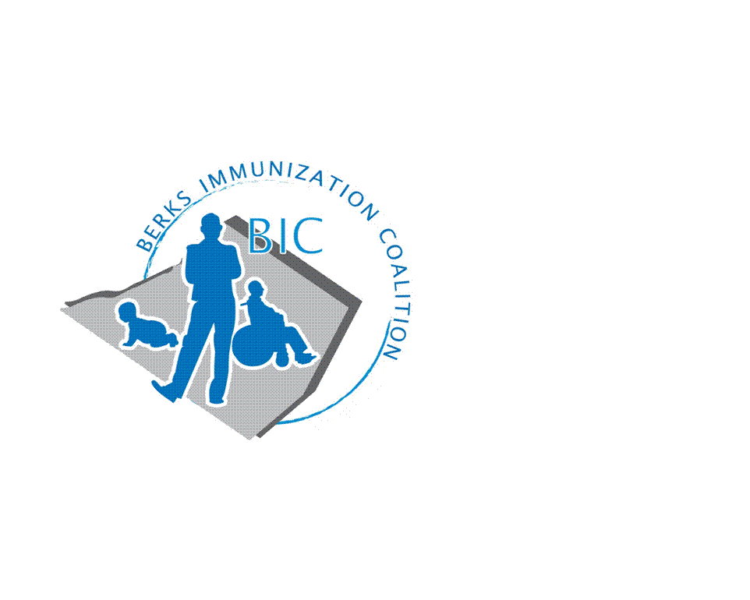
BERKS IMMUNIZATION COALITION
GENERAL MEETING MINUTES
June 29, 2021

Attendees: Maria Alicea, Nicole Berger, Deana Cortina, Anne Fisher, Rose Grill, Cindy Hinsey, Sarah Kinsey, Andy Krug, Jessica Long, Tracy Ravert, Tracy Scheirer, Tara Smith, Beth Till, Kim Young,
OLD BUSINESS
  - Approval of Minutes – Tracy Ravert, Rose Grill
  - Treasury Report -Balance $10,476.69
  - DOH Report – No reported VPD’s (other than COVID) in the 1st quarter
- NEW BUSINESS
  - DOH involvement in BIC meetings
    - Rose Grill will reach out to DOH supervisor but no guarantee due to high workload
  - COVID vaccine
    - Vaccine availability – Large distribution centers are closing, smaller community pharmacies administering vaccines
    - COVID statistics in PA last 2 weeks –7 new cases, 6 hospitalizations, no admissions to ICU, no new deaths
    - COVID vaccines given to date in PA—175,000
    - Tracy S. – Students encouraged to receive vaccine, once FDA approval COVID vaccine will be required.
    - Schools
      - Masking – Per Ann schools will have their own guidelines. Federally funded schools will need to renew health and safety plan by July.
      - Testing – Gov’t will fund for testing of staff and students
      - COVID 19 Vaccine clinics – Possibly to be held at food distribution sites
      - Raffles – children who receive 2nd dose of COVID 19 vaccine will be eligible for raffle giveaways.
    - Montgomery County – Hosting events with raffles for COVID vaccine. 70 individuals were vaccinated at this event. AmVAXador program www. Montcopa.org/AmVAXador COVID vaccine focus is on black community, specifically 20-30 y.o. due to having the lowest vaccine rates.
  - Catch-up Vaccine
    - Reading Area School District
      - Vaccine clinic during school year 1 day/week
      - Additional clinics during summer for high school students
        - 100 appts/week for three weeks
      - Middle school students can be vaccinated on site during school year
  - Planning Activities 2021
- Tracy S. reached out to Eric White, Redner’s Markets for space in their quarterly magazine to promote immunizations. Missed July publication, Tracy S. and Tracy R. will pen an article for the October issue. Focus will be on general immunizations.
- Educational update dinner event for fall: target month November for school nurses, student nurses, office nurses, MA’s. Bonus event can offer CEU’s
      - Tara Smith mentioned the Dr. Niki Parkinson, Merck, is also available for educational programs that are non-branded
      - Sarah has contact, Dr. Almira Contractor from York County, is a WellSpan pediatrician. Not sure how long the presentation is, will speak with her.
      - Andy is able to reach out to survivor to speak at event
- Fightin Phils – August 1st
      - Tracy S., Tracy R., Beth G., Nicole B., (Jes L., Mia A.- possibly able to attend)
        - If you need a polo email Tracy S.
      - Spotlight press box with Redner’s
      - Approval of $500 for giveaway purchase
  - Planning Activities 2022
    - Reading Royals – Cindy Hinsey has contact and can reach out about a table during season.
    - School participation
      - Ideas- Video contest for high school students, poster campaign for school age, jingle for music students
  - Other items of discussion
    - Tri-county Health Council Community Town hall will be held July 22nd or August 5th: COVID 19 vaccine and routine vaccines for children
  - Meeting Dates for 2021 – September 28, December 28

Respectfully submitted,
Nicole
Nicole Berger, RN
Berks Immunization Coalition Secretary

