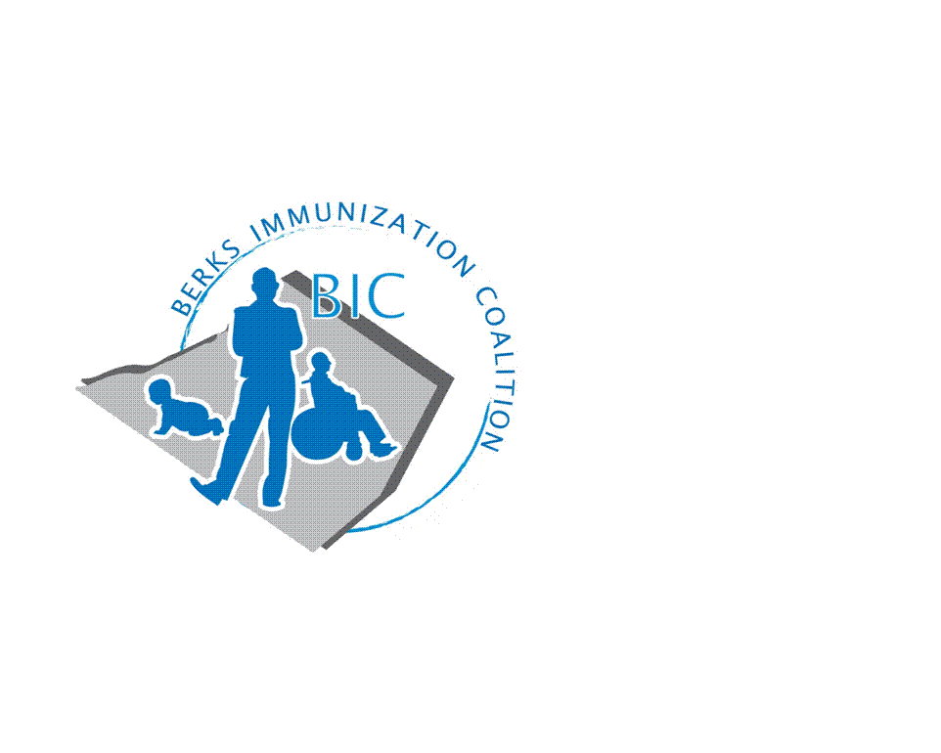
BERKS IMMUNIZATION COALITION
GENERAL MEETING MINUTES
September 17, 2019

Attendees: Harryl Allen, Rose Grill, Cindy Hinsey, Eve Kimball, Andy Krug, Maria Melendez, Kim Moleski, Tracy Scheirer, Tara Smith, Karen Wang, Kim Young
- OLD BUSINESS
  - Approval of Minutes – Kim Moleski, Rose Grill
  - Treasury Report – No changes, funds remain a $3776.69. Tara Livinghouse has resigned as Treasurer. Please consider volunteering for this position. Time required is minimal. If interested, contact Tracy Scheirer.
  - DOH Report – Sporadic cases of varicella, pertussis in Berks County. No outbreaks. Discussion on measles and the current Hepatitis A outbreak that is affecting the state. A $50,000.00 grant from Governor Wolf was awarded to purchase Hep A vaccines to be distributed in Pittsburgh, Bethlehem, Allentown, and Philadelphia.
  - PIC Meeting June 27th – Harryl stated that attendance was increased from previous years, over 350 attendees. This was the first year that media coverage was present. The Planning Committee is working on next year’s conference which will be held at the Harrisburg Hilton on June 18, 2020 with the PAIC meeting on June 17, 2020.
  - Bus Campaign – Bus logo – Don’t Wait, Vaccinate! It’s a general message that is easy to understand. A QR code will be included with a short survey. Tracy Ravert has all the materials and Tracy R. and Tracy S. will finalize the project.
  - August 4th – Fightin’ Phils game was a success. Thanks to volunteers Tracy R., Tracy S., Kim and Nicole! Many kids were in attendance, Harry Potter theme day. Redner’s was not able to support us this year, however BIC was given a 50% discount to participate. Cost $500. This is a high-profile event for the BIC and the group decided to continue yearly. Please see attachment for pictures of the event. Volunteers spoke with many families regarding the importance of immunizations and the kids enjoyed the giveaways of lip balm, crayons and nylon back packs with the BIC logo. Tracy S. was interviewed on local radio during the 3rd inning.
  - New Twitter account @BerksCoalition. Please share!
- NEW BUSINESS
  - Planning Activities
    - Bus campaign is ready to launch
    - Idea for Teen Video Challenge. Work with Junior HS school nurses, art teachers and IT departments to create a teen-focused video message about importance of vaccination in the teen population. The group agreed that this would be a great project for 2020. Will revisit at the January 2020 meeting.
    - Cindy Hinsey suggested BIC exposure at a Reading Royals game. She will find out a contact person.
- Legislative Committee
  - Contact your legislators with vaccine issues
    - www.legis.state.pa.us/cfdocs/legis/home/find.cfm
    - Harryl reported that Rep. Frankel entered, in this session, to not remove the personal exemption from school law, but to require parents to speak with a counselor on a yearly basis regarding immunization for their child/children.
- Anything Else
  - Maria Melendez reported that she educated all Berks Community Health Center sites on measles and MMR vaccine. She will also be interviewed on Albright College Spanish Radio in early 2020 regarding vaccinations
  - Tracy S. has done several talks to the Consumer Science classes at Exeter High School.
  - Health Editor at Reading Eagle has resigned.
- Other Meeting Dates
  - Meeting dates for 2020 – January 21, March 31, June 30 and September 29. Meetings will be held on Tuesdays next year.

Respectfully submitted,
Rose
Rosemary Grill, RN
Berks Immunization Coalition Secretary

