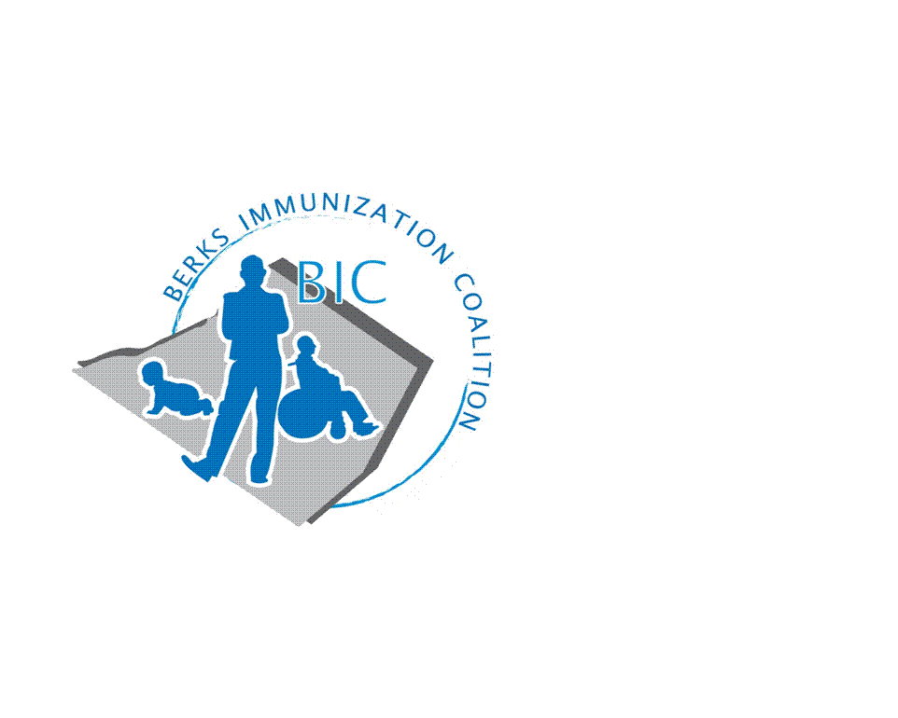
BERKS IMMUNIZATION COALITION
GENERAL MEETING MINUTES for 9-26-17
Attendees: Harryl Allen, Duane Daniels, Raine Fussner, Rose Grill, Mike McBride, Kim Moleski, Cherie Raub, Tracy Ravert, Tracy Scheirer, Tara Smith, Marisa Swisher, Lynne Timby, Stacey Lattanze, Lucille Hawkins, Yazmin Rodriguez and Stefanie Schmitz

- OLD BUSINESS
  - Approval of minutes from 6-28-17 meeting. Kim Moleski seconded by Tracy Ravert
  - Treasury Report – Current balance $4400
    - $690 reimbursement to Tracy S. for Senior Expo
  - DOH Report
    - Duane Daniels reported on school catch-up clinic at McCaskey High School in Lancaster. Poor turnout of only 44 students even though reminder calls went to all excluded students (400). Berks SHC added three extra back to school and catch-up clinics.
  - Reading School District VFC Clinics
    - Tracy Ravert reported that the school district held clinics weekly all summer and immunized only 120 students. After exclusion three weeks of after school clinics were held. A total of 700 students were immunized. On day one of school there were 2200 students who still needed immunizations. As of today, only 75 remain and those students are still excluded. Students are sent to truancy after 10 missed days.
    - Weekly clinics are booked until the end of October. The district is seeing an influx of displaced children from Puerto Rico and Texas without immunization records.
      - It was suggested by Harryl Allen to contact Harrisburg regarding possible temporary waivers for immunizations as was done for hurricane Katina. Rose will address with Harrisburg.
  - August 6 Fightins Game – Good turn-out. Thanks to Team Tracy!! Thank you, Eric, for supplying promotional items. Tracy S. was interviewed on local radio.
  - #UDontgetit in school campaign for teens
    - Still attempting to get graphics for bus campaign. Harryl stated that the Commonwealth has rights to all materials. Lynne Timby will send to Tracy R. and Tracy S.
  - PAIC Update
    - Harryl secured a grant for $100,000/year for 5 years. PAAAP will act as Fiscal Agent for PAIC. Dr. Brenner secured a legislative grant for $200,000 which is currently on hold in the Governor’s office.
    - PAIC plans to restart the #UDontgetit Phase 4.
    - There may be the possibility of mini-grants which will be managed through PAAAP.
    - PAIC President, Lynn Robertson and Treasurer, Gail Wright.

- NEW BUSINESS
  - Planning Activities
    - Membership and recruitment committee needed
    - Senior Expo October 24th from 9-3 at the Double Tree. Tracy S, Duane and Rose will participate. A ½ page add is included in the registration price. Any ideas for the add please send to Tracy S.
    - Plans for 2018 focus
      - Phillies game in August 2018 for Immunization Awareness Month
      - #UDontgetit Bus Campaign – Tracy R.
      - NIIW end of April
      - HPV Awareness Month January 2018. Possible kick off bus campaign at this time
      - Medical Assistant Training Program – IZ techniques, Storage and Handling, speaker. Rose will attend Bucks County Coalition Program on October 10 to observe. If we decided to proceed, Rose and Marisa will spearhead the project. Other volunteers will be needed.
        - Stefanie stated that immunize.org did a similar nation-wide campaign that was very successful.
    - Legislative Committee
      - Contact your legislators with vaccine issues.
        - www.legis.state.pa.us/cfdocs/legis/home/find.cfm
    - 24th Annual PA Immunization Conference – August 16, 2018 at the Harrisburg Hilton
    - 2018 Meeting Dates – January 23, March 13, June 27 and September 25.

Respectfully submitted,

Rosemary Grill, RN
Berks Immunization Coalition Secretary

