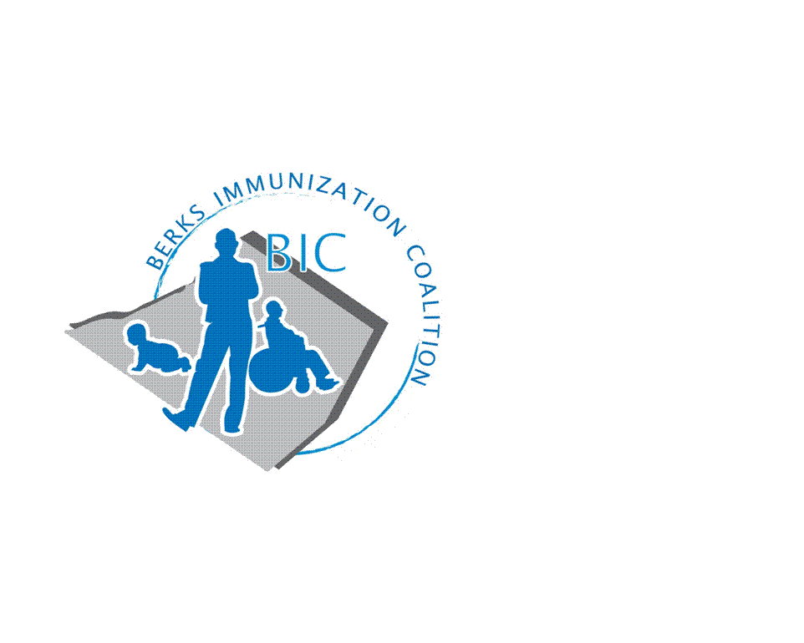
BERKS IMMUNIZATION COALITION
GENERAL MEETING MINUTES
September 27, 2022

Attendees: Nicole Berger, Karen Wang, Jes Long, Andy Krug, Tracy Scheirer, Lisa Reiter, Marnita Hartline, Joanne Walsh, Tara Smith, Sarah Kinsey, Rachel Hahn, Stephanie Mihailescu
OLD BUSINESS
  - Approval of Minutes – approved- Lisa and Tara
  - Treasury Report -Balance $9559.76 at Diamond Credit Union
    - Promotional items purchased over summer
    - Tracy and Tracy R. still waiting to transition treasury account holder
  - DOH Report – Tracy: possible higher than normal flu season- drop in mask mandates, no social distancing
- NEW BUSINESS
  - Continuing grant- now in year 2. Lots of ideas, need more people to help execute
    - Rachel- 8.8.22 radio ads with iheart radio mention covid vaxx but also back to school and routine vaxx for adults and children running through Oct 20.
      - Webinar in the works-- safe communities and coalition action fund- Becky Christiansen- promote vaccine legislation- plan for October 13th, lunchtime webinar
      - outright campaign- will focus more on digital ads this year as opposed to billboards. newsletter- survey to nominate vaccine champions advocate in the community.
      - In the works of planning a photoshoot.
  - Tracy- wants to plan a big event for 2023. Cindy Hinsey already reached out to reading royals for an event tabling at one of the games
    - Space at Alvernia for dinner, Rachel says they are hosting an event and will have guest speaker- hybrid event. Form committee- Nicole tracy, jes long (general vaccine update)
  - DOH replacement- no word at this time who is going to replace Rose, Peggy Glass visiting practices
  - COVID vaccine
    - Pfizer and Moderna are recommending a 4th dose of vaccine
  - Educational Outreach Program
    - BIC at Fightin Phils
      - Promotional items- crayons, water bottles, string bags
      - Great giveaways thanks to Rachel who helped pick them out, new table cloth and pop up tent
      - Approx. 400 people that we talked to. They have done away with the third inning radio spot. Don’t have an interest in continuing the radio spot. Reach out locally to WEEU
    - Outreach and PAIC Website
      - Rachel is the Point of Contact and listed on website to get new attendees
        - YMCA August 25th vaccine clinic- vaccinated 17 people and large age range 10 mos to 70 years both primary and boosters, contracted with DOH- Peggy Glass for vaccine, had bilingual nurse
    - Grant proposal included reaching out to community churches, hairdressers and barbers for getting info out to the community
      - Increase vaccine rates by one person at a time may be the way to go
      - What other ways could we promote vaccination?
    - Grant- two small grants for:
      - Shillington Medicine Shoppe- has taken on a lot of opportunity to vaccinate uninsured and underinsured through donations.
      - THAH- Lisa Reiter- forced to move from current facility to a different facility. Plan for developing an outpatient clinic. Dr. Wang is going to find out why providers aren’t offering VFC vaccine. Who is this serving and how are they best served. Tara suggested state health dept in reading to hold a vaccine clinic- lisa did talk to Peggy but she did not address that with her. Tara also states 138 S. 6th street. Amish community most go to Topton Family Practice for primary care but they do not do vaccines there- Lisa will reach out
    - Meeting Dates – Meet on November 29th and the rest of the meeting dates for 23 will be every other month.

Respectfully submitted,
Nicole
Nicole Berger, RN
Berks Immunization Coalition Secretary

