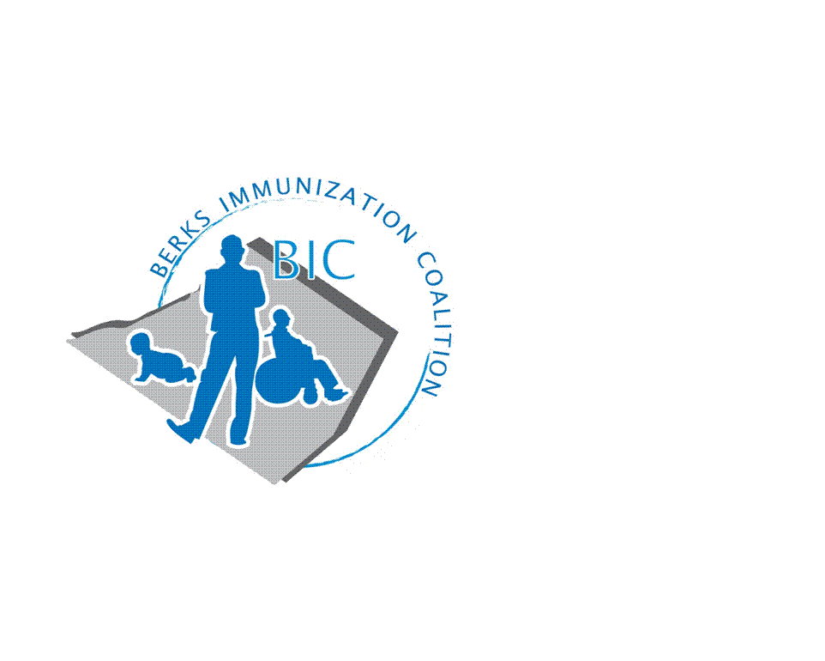
BERKS IMMUNIZATION COALITION
GENERAL MEETING MINUTES
September 28, 2021

Attendees: Nicole Berger, Tom Dumas, Jennifer Fulton, Sarah Kinsey, Kayla Knock, Andy Krug, Tracy Scheirer, Tara Smith
OLD BUSINESS
  - Approval of Minutes – Sarah Kinsey, Tracy Scheirer
  - Treasury Report -Balance $10,476.69
    - Approximately $800 spent in promotional items that have not been deducted from funds at this time
  - DOH Report –
- NEW BUSINESS
  - DOH replacement- no word at this time who is going to replace Rose
  - COVID vaccine
    - Vaccine hesitancy – young adults, need to educate
    - Booster- Large community booster plans: vaccine to be available in pharmacies and doctor’s offices
      - Flu and booster able to be administered together
  - PAIP Grant
    - Kayla- PAIP received grant opportunity: $100K project funding is for FY now to June 2022
      - Part time (15-25 hrs/wk) job description to cover BIC marketing and communications. Looking for new grad with a public health degree.
      - PAIP to manage individual
      - Work together with Schuylkill and Montgomery
  - Tom Domas from GSK- Medical Support
    - Able to assist and educate regarding vaccines
    - Access to data
  - Meeting Dates – January 18, March 29, June 28, September 27

Respectfully submitted,
Nicole
Nicole Berger, RN
Berks Immunization Coalition Secretary

