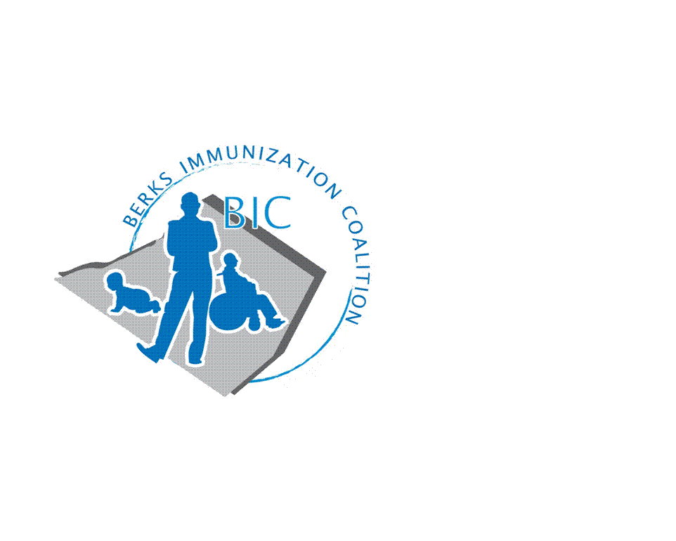
BERKS IMMUNIZATION COALITION
GENERAL MEETING MINUTES
September 29, 2020

Attendees: Beth Till, Nicole Berger, John Vogel, Kim Moleski, Sarah Kinsey, Tara Smith, Tracy Ravert, Lisa Reiter, Kim Young, Tracy Schierer, Rose Grill, Cheryl Byrne, Deana Cortino, Cindy Hinsey, Alvernia Nursing Students
- OLD BUSINESS
  - Treasury Report – New Treasure, Tracey Ravert, was confirmed by the group. Thank you, Tracy!
    - Balance - $10,476.69
  - DOH Report – Rose reported minimal VPD’s. From the period of July 1-September 29 there were 3 cases of Pertussis and 2 cases of Varicella reported through the PA NEDSS system.
  - Twitter Account @BerksCoalition. Please share!
  - Bus Campaign – Tracy asked if the group had seen any buses in Berks participating in the PAIC bus campaign. No reports of bus sightings.

- NEW BUSINESS
  - Teen Video Challenge – on hold, may not be the right time as student would need to congregate – will re-visit in 2021.
  - Advocacy ideas for COVID age. What can we do?
    - Thomas Dumas, Medical Liaison, GSK, reached out to Tracy S. asking how he could support us. Possibly a virtual educational dinner. Cheryl Byrne will reach out to Thomas.
    - Virtual showing of movie – Someone You Love. Beth Till reported that Indiana State Coalition did this, Communications Manager Patrick Glew. Beth will reach out to Patrick on how this was accomplished. Panel discussion afterwards. Tara Smith will check with Dr. Kelleher and Dr. Wong from Berks Community Health Center to see if they would be willing to participate.
    - Other ideas
      - Twitter Campaign
      - School essay contest – Healthcare focused, vaccine advocacy, ethics of vaccinations (debate team).
      - CDC “You Call the Shots” modules contest. Upload/email your certificates for a prize drawing.
  - Alvernia students were asked about social media platforms. They stated that younger people tend to use Instagram and Twitter while their parents use Facebook.
  - Flu/Immunizations Update
    - Kim Moleski reported that Tower Health will begin their employee flu campaign on October 1.
    - Beth Till reported that anyone who lives or works in Montgomery County is eligible for flu vaccine. MCHD is holding drive-thru and walk-in flu clinics. Visit montcopa.org/flu for more information. This could affect Berks County residents that are close to the Montgomery County border.
    - John Vogel reported that seniors are confused as to when to receive their flu shots. Sarah Kinsey stated the latest guideline are in the MMWR #34 August 21, 2020.
    - Tracy Ravert – Reading School District – reported the nurses are running three clinics/week while school is virtual and will cut back to one/week when live learning returns. Parents are not understanding that immunization laws pertain to all students regardless if education is virtual or live instruction. High no show rates. There are currently 600 provisional students at Reading High.
    - Lisa Reiter, Tower Health at Home, reported they are awaiting grant funding to continue immunization clinics, but it does not look hopeful. Will know by the end of November. $141,000 is available and $900,000 was applied for by 36 different entities. Minimal funding is left through November. No show rate is approximately 25%. If anyone has any suggestions, you may reach Lisa at Lisa.Reiter@towerhealth.org.
    - It was suggested the Reading Council of Churches could be a partner for flu information. John Vogel sits on the Board.
  - Legislative Committee
    - Contact your legislators with vaccine issues – www.legis.state.pa.us/cfdocs/legis/home/find.cfm
    - John reported that there are several pieces of legislation regarding COVID vaccine in the PA legislature
  - Other items of discussion
    - Nicole Berger, All About Children, reported that they sponsor a grandparent’s support, group for those finding themselves raising their grandchildren. Please see attachment for me information.
  - Meeting Dates for 2021. January 12, March 30, June 29, September 28.
    - https://alvernia.zoom.us/j/8248213418

Respectfully submitted,
Rose
Rosemary Grill, RN
Berks Immunization Coalition Secretary

