Dear [Insert Patient Name]:
Many people often think that only children need vaccinations to help protect them against diseases like the flu, pneumococcal disease, tetanus, and others. However, each year thousands of adults suffer illnesses, hospitalizations, and, in serious cases, even death from diseases that may have been preventable with adult vaccinations.1

Possible Complications from VPDs in Adults2-8

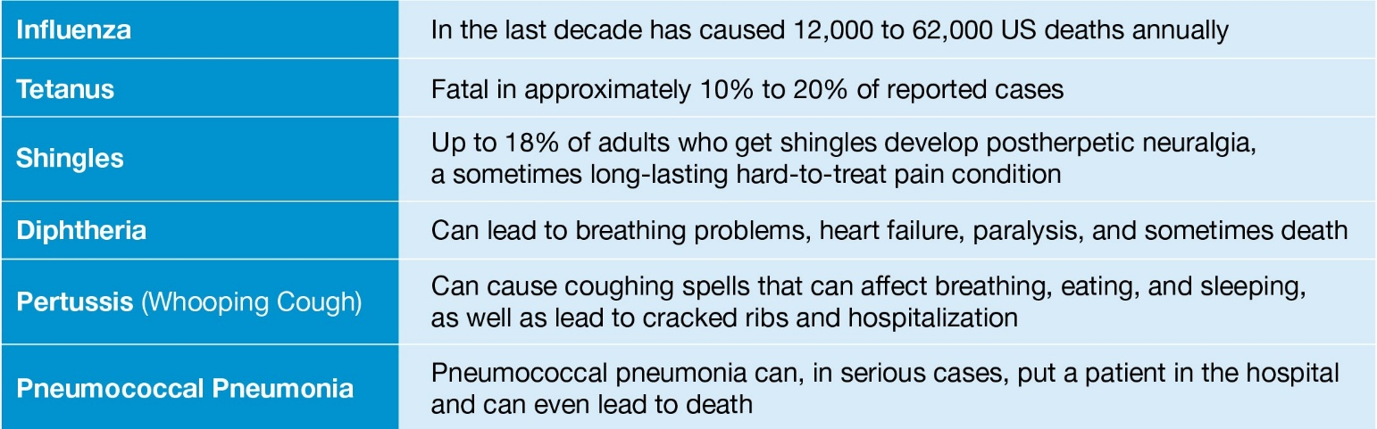

Many people dismiss pneumococcal pneumonia as an illness that only the elderly or sick people get in the hospital. However, anyone can get pneumococcal disease.9

Some symptoms of pneumococcal pneumonia include8
- High fever and shaking chills
- Chest pain with difficulty breathing
- Cough with phlegm that persists or gets worse
Getting vaccinated may help protect against potentially serious diseases, including pneumococcal pneumonia.

Talk with your doctor about the risks of VPDs, like pneumococcal pneumonia, and to see if certain adult vaccinations may be right for you

Sincerely,
[Insert Name]
[Insert Title]
[Insert Provider Name]

References: 1. Centers for Disease Control and Prevention (CDC). Why vaccines are important for you. https://www.cdc.gov/vaccines/adults/reasons-to- vaccinate.html. Updated May 2, 2016. Accessed August 3, 2020. 2. CDC. 2019-2020 U.S. flu season: preliminary burden estimates.
https://www.cdc.gov/flu/about/burden/preliminary-in-season-estimates.htm. Last reviewed April 17, 2020. Accessed August 3, 2020. 3. CDC. Past seasons estimated influenza disease burden. https://www.cdc.gov/flu/about/burden/past-seasons.html. Last reviewed January 9, 2020. Accessed June 26, 2020.
4. National Foundation for Infectious Diseases (NFID). Tetanus questions and answers. https://immunize.org/catg.d/p4220.pdf. June 2020. Accessed August 3, 2020. 5. CDC. Shingles burden and trends. https://www.cdc.gov/shingles/surveillance.html. Updated August 14, 2019. Accessed August 3, 2020. 6. NFID. Diphtheria. https://www.nfid.org/infectious-diseases/diphtheria. Accessed August 3, 2020. 7. NFID. Whooping cough (pertussis). http://www.adultvaccination.org/vpd/pertussis. Accessed August 3, 2020. 8. CDC. Pneumococcal disease. In: Hamborsky J, Kroger A, Wolfe S, eds. Epidemiology and Prevention of Vaccine-Preventable Diseases. 13th ed. Washington, DC: Public Health Foundation; 2015:278-296. 9. CDC. Pneumococcal disease: risk factors and transmission. https://www.cdc.gov/pneumococcal/about/risk-transmission.html. September 6, 2017. Accessed August 3, 2020.

PP-PNA-USA-4378-03 © 2020 Pfizer Inc. All rights reserved. October 20

