Meeting called by: MCIC Type of meeting: MCIC General Meeting
Facilitator: Maureen A. Hennessey Note taker: Monica Giacomucci
Location: Zoom Date/Time: September 9, 2020
Time: 9:00 – 10:30 am

In attendance: Maureen Hennessey, Kalyn Roberts, Cierra Gomez, Susan Wenrick, Lynne Timby, Beth Till, Monica Giacomucci, Susan Smith, Mae Lynn Forzato, Carrissa Nandlal, Tracey Blickos, Heather Entenmann, Mary Kay Horgan, Kerry Mulvey, Brenda Anastasio, Amy Wishner, Willie Mae Bell, Andrea Kauffman, Sarah Hoover, Donna Rabena, Mary Alice DiFilippo, Kimberly Perry-Malloy, Helen Cline, Billie Osborne, Sam Calarco, Ruth Cole, Thomas Dumas

Treasurer’s Report
- MCIC funds: $34,366 (+5.00 to keep account active)
- Immunization grant July 1, 2021 – June 30, 2021:
  - Awaiting additional funds from State ($450,000 total)
  - Funding for Seasonal Flu vaccination COVID-19 campaigns and outreach
  - Allocate $200,000 for MCIC
    - flu outreach and new paid position (Communications Manager) and hire a media agency
    - Request for Proposals out for Media Agency
Presentation: MCIC Flu Committee (Beth Till, Communications Manager & Kalyn Roberts, Immunization Program Supervisor)
- Slides attached
- Immunizations and communications need to work together
- Gather stakeholders and input and share resources
- Flu text campaign launched – partnership with Families Fighting Flu
- Montgomery County Flu webpage – One stop shop/Share resources from partner organizations
- Flu Flyer shared with notes
- OPH will offer drive through flu clinics throughout County - final details will be released soon
- OPH COVID-19 testing sites will be used for walk-up flu shot clinics
- OPH will offer flu vaccine at health centers as well
- Amy Wisher shared information on an upcoming flu webinar (shared with General members on 9/9)
Election of Officers
- All positions up for vote, no objections from floor. All positions approved.
  - Maureen A. Hennessey, Chair
  - Susan Wenrick, Vice Chair
  - Kalyn Roberts, Treasurer
  - Monica Giacomucci, Secretary

Committee Reports/Projects
- 2021 Annual MCIC Immunization Dinner for Healthcare Professionals
  - Date confirmed: May 19, 2021 at Presidential Caterers
  - Same speakers as 2020 (cancelled) dinner have been asked to participate
  - Help is welcomed with Steering Committee
- Victor Vaccine Activities – on hiatus due to COVID-19
- Events
  - Norristown Voter Registration Event 9/12/2020
Beth and Public Health nurses – information and flu shots available
Other Business:
- MCIC now has an Instagram page – please follow and share
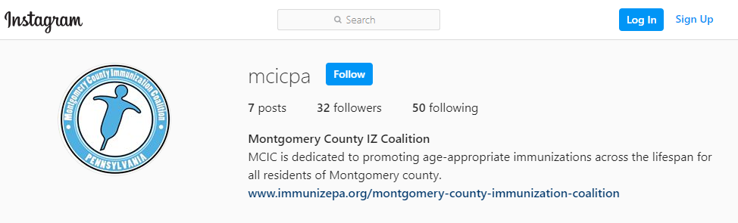
2020 – 2021 Meeting Dates
General Meetings  8:30 am: Networking / 9:00 am: Meeting begins | Steering Committee Meetings  9:00 to 11:00 am
Wednesday, December 9, 2020 | Tuesday, October 13, 2020
Wednesday, March 10, 2021 | Tuesday, January 12, 2021
Wednesday, September 8, 2021 | Tuesday, April 13, 2021
Wednesday, December 8, 2021 | Tuesday, July 13, 2021
 | Tuesday, October 12, 2021
2021 Annual MCIC Dinner: May 19, 2021

