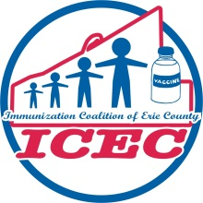

Immunization Coalition of Erie County Meeting Minutes
June 21, 2018 - 11:30 am-1:00 pm
Erie County Department of Health 2nd Floor Conference Room

MEMBERS IN ATTENDANCE |  | MEMBERS IN ATTENDANCE
RK (Ronald) Bair, Senior Regional Acct Mgt. Sanofi Pasteur |  | Darrel Romba, Immunization Coordinator at WIC
Kris Balinski, ECDH IMMI Supervisor |  | Sonya Shampoe, ECDH Public Health Nurse, VFC QI Nurse
Maggie Burrows, ECDH – Outreach Worker |  | Janet Strayer, ECDH Public Health Nurse
Tonie Cline, ECDH, Project Secretary |  | Meghan White, Merck
Kevin Louis, Sanofi Pasteur * CO-CHAIR |  | Karen Wiggers, BS, RN ECDH Public Health Nurse * CHAIR

- Welcome and Introductions – Chair, Karen Wiggers, BS,RN
Karen welcomed everyone to the meeting and the group members introduced themselves.
Welcome new member RK Bair from Sanofi Pasteur.
Reviewed and approved minutes from March 15, 2018 meeting.

II. Ice Breaker – Co-Chair, Kevin Louis
100 years ago the Great Influenza Pandemic killed between 50M-100M people world-wide.
Take a True/False test of 10 questions and learn influenza facts at
https://www.smithsonianmag.com/history/ten-myths-about-1918-flu-pandemic
Other interesting sites on 1918 flu pandemic:
https://wwwnc.cdc.gov/eid/article/12/1/05-0979
https://ecdc.europa.eu/en/seasonal-influenza/facts/questions-and-answers-influenza-pandemics

III. Flu – Review and Preview-Co-Chair, Kevin Louis
WHO (World Health Organization) changes 2 strains for 2018-19 flu vaccine.
https://www.printfriendly.com/p/g/E9Xd8q
Kevin stated that UPMC is trying to go to all egg free flu vaccine with FLUBLOK-FDA approved age 18 older and
Flucelvax from Seqirus for age 4 and older.
https://www.passporthealthusa.com/vaccinations/flublok-egg-free-cell-based-influenza-vaccine/
https://www.flucelvax.com/

Karen presented graphs of Influenza Cases by Season for Erie County, PA see attachments by:
Percent of Influenza Cases by Age
Reported Influenza Cases by Type
Hospitalized Influenza Cases

The World’s First Universal Flu Vaccine is already undergoing clinical trials.
https://www.sciencealert.com/universal-flu-vaccine-funded-by-gv-clinical-trials

Using spider silk to boost our immune systems
https://www.medicalnewstoday.com/articles/322139.php

IV. Hot Topics, Karen
Travel Health Notices-Warnings:
#3-Venezuela – avoid non-essential travel
#2- Practice Enhanced Precautions – Brazil-Yellow Fever, South Africa-Malaria and Listeriosis
#1-Practice Usual Precautions- Democratic Republic of Congo-Ebola, Saudi Arabia-Hajj and Umrah, Italy-Measles.
https://wwwnc.cdc.gov/travel

V. PA Immunization Conference-Harrisburg 8/16/18– Karen
https://ce.med.psu.edu/pennsylvania-immunization-conference/

VI. National Immunization Awareness Month-AUGUST – Karen
https://www.nphic.org/niam-10things
Childhood Immunization Drop-In Article for Public; also in Spanish.
Send Your Kids Back to School with Their Vaccines Up to Date.
Vaccinating on Time is Important for Disease Protection
Five Important Reasons to Vaccinate Your Child
https://www.cdc.gov/vaccines/partners/childhood/matte-articles-features.html

ICEC sponsored Baseball game: SeaWolves is Tuesday, August 21, 2018.
You will be notified when vouchers are available.

VII 2018 Professional Immunization Conference-Friday, October 26, 2018-Karen
Ambassador Center, Erie, PA (Peach Street/I-90)
https://www.emedevents.com/c/medical-conferences-2018/2018-professional-immunization-seminar

VIII. Discussion From the Floor – Please bring your ideas-Karen
Meghan White, Merck: Manufacturer for GARDASIL®9 stated that the American Cancer Society is heading their own
HPV campaign. The National Goal is 80% vaccinated for females and males.

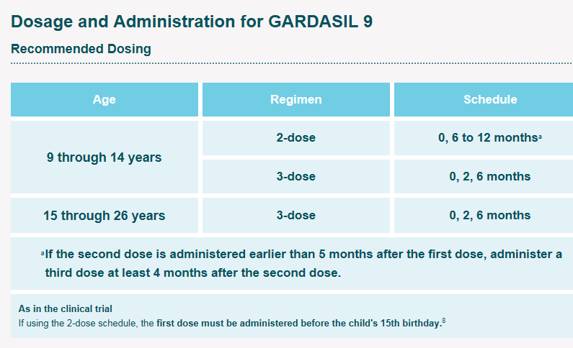
Merck will run their HPV campaign in parallel.
Breaking news: GARDASIL®9 is being investigated for ages 27 through 49.

RK Bair, Sanofi Pasteur: Talked about Project Tycho.
University of Pittsburgh project to advance the availability and use of public health data for science and policy making.
The Project Tycho™ database includes data from all weekly notifiable disease reports for the U.S. dating back to 1888.
Data are freely available to anybody interested. Updated 2.0 version coming in August 2018.
https://www.tycho.pitt.edu/data/

IX. Next Meeting: November 15, 2018 - Karen Amendment: Meeting changed to November 29, 2018.
Erie County Department of Health-606 West 2nd Street, Erie, PA 16507, 11:30am to 1:00pm, 2nd Fl. Conf. Rm.
(Bring your own Lunch)

