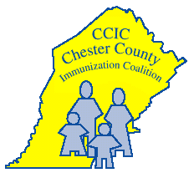
Join the herd. Get vaccinated on time!

Chester County Immunization Coalition
www.immunizepa.org

601 Westtown Road, Suite 180, West Chester, PA 19380
610-344-6252 FAX 610-344-5405

August is National Immunization Awareness Month.
Please help us celebrate!

Dear Chester County Libraries,

August is National Immunization Awareness Month (NIAM). The Chester County Immunization Coalition and the Chester County Health Department invite you to raise community awareness about the important role vaccines play in preventing serious, sometimes deadly diseases across one’s lifespan.

Each week of August highlights a specific age group and the recommended vaccines:
- A Healthy Start (August 3-9)
- Back to School (August 10-16)
- Off to the Future (August 17-23)
- Not Just for Kids (August 24-30)

Please distribute these bookmarks in August to get the word out about vaccines for health at all ages that includes a link to the Center for Disease Control vaccine quiz to help families determine what vaccines are recommended for each member of the family. Please contact lharbage@chesco.org if you would like more bookmarks or educational materials for your library community.

For more information about NIAM, please visit the Centers for Disease Control and Prevention or the American Academy of Pediatrics Immunization Initiatives websites:
http://www.cdc.gov/vaccines/events/niam.html
http://www2.aap.org/immunization/about/niam.html

Thank you for collaborating to raise awareness of the vital role vaccines play in the health of our community, nation and world.

Best regards,
Laura Harbage BSN RN
Public Health Nurse
Chester County Health Department
Chair Chester County Immunization Coalition
610-344-5565 lharbage@chesco.org

