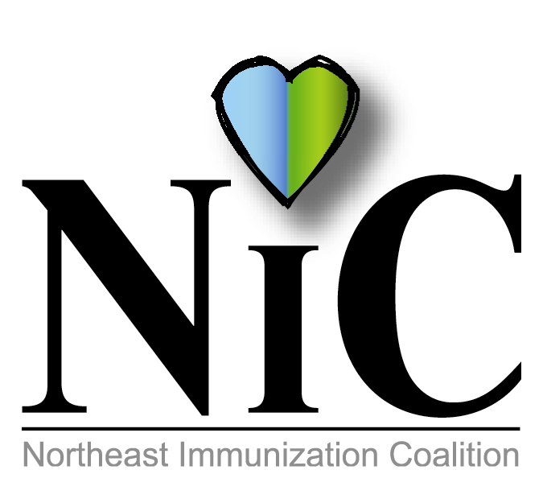

NIC MINUTES, 5-4-2018

The meeting was held at the WBCHD, Kirby Health Center, 71 N Franklin Street in Wilkes Barre at 10:30 A.M.
In attendance: Delphine Torbik,WBCHD; Nicole Amos, WBCHD; Donna Reilly, retired school nurse from Wilkes Barre School District; Stefanie Schmitz, GSK; Jenni Maccho, GSK; Terry Metcalf, DOH; Bill Court, DOH; Joan Mueller, community; Mark Solomon, Sanofi; Denise Spinelli, John Heinz; Anne Manganello, Valley Peds; Lori Conway, LIU; Eileen Attar, Surgical Specialty Care; Jane Osborn, DOH; and Adria Laboy, Etna.
Welcome and introductions were done.
REVIEW MAY MINUTES:
Minutes were reviewed and accepted.
FISCAL REPORT:
We needed to spend 1500.00 by end of June. We spent $1037.00 on immunization coloring books purchased from Color Junction. These are the same coloring books we used in the past. We ordered 1000 of them. After June we will have another 1500 from Wilkes Barre City and still have funds from CEO.

HEALTH KIDS DAYS DAY AT YMCA;
April 21-Wilkes Barre YMCA and Dunmore YMCA
Mary from Head Start volunteered to represent NIC. She reported beginning of the day was slow, but things did pick up. She gave out 125 coloring books along with some pens and bracelets. She also pushed a lot of information on HPV vaccine
Bill also attended this event in Dunmore. He reported it was very busy in the morning and then things slowed down. He handed out approximately 75 refrigerator clips, pencils and immunization information.

DIGITAL SIGN:
Delphine stated that Wilkes Barre has a digital sign located on Wilkes-Bare Blvd. We can promote vaccine at any time for no cost. This sign is located in a very good location with lots of car traffic. We used it to promote NIIW April 21 to April 28 “Infants...Love them, protect them, immunize them”

ROSCOE BENCH:
These are benches located throughout Luzerne County. They are used for advertisement. They are placed in high traffic areas. Cost is $70.00 per month with a one month set-up fee. 6 month minimum contract. Group had discussion on these benches and decided to “bench” the idea at this time.

LETTER TO CAMP ADMINISTRATORS:
Terry discussed the letter to camp administrators. We are planning to send a letter out to camp administrators in the 7 counties getting camps involved in making sure their kids are up to date on vaccines. Jane will help in developing the letter.

48th NATIONAL IMMUNIZATION CONFERENCE
This event brings together 1500 local, state, federal and private immunization stakeholders together. Theme this year is “Prevention, Protection and Progress”. This conference will be held May 15-17 in Atlanta. Delphine and Stephanie will be attending. They also look forward to bring new and innovative ideas back to our coalition.

NATIONAL IMMUNIZATION AWARENESS MONTH:
This is an annual observance to highlight the importance of vaccination for people of all ages. Every week is dedicated to a different group. We do not have another meeting before August. Group discussed doing the bus project again. We did this project back in 2011. It was a huge success. The group also decided to try to do this project elsewhere other than Luzerne County. We would like to target Hazleton. Terry volunteered to do some searching for us, regarding cost, etc. Adria is also going to forward Delphine information about advertising in Monroe County.

MASCOT:
Since our mascot is MIA Delphine presented 20 possible mascots to represent our coalition should we decide to purchase another one. Discussion ensued. Adria and Mark are taking home the top 5 chosen and show them to their children for their input.

OTHER:
Group discussed also doing initiatives at the Railriders. Denise is going to look into this idea more thoroughly. She will call and get info and costs of promoting.

In 2012 the coalition put out a survey to their members. We will be sending out another one. Please take the time to answer honestly and return it. Thank you in advance.

NEXT MEETING LOCATION AND TIME:

Sept 7, 2018
Nov 2, 2017

Meetings will take place at Kirby Health Center, 71 N Franklin St. Wilkes-Barre, PA 18701.

OUR WEBSITE: https://www.immunizepa.org/northeast-immunization-coalition/

Respectfully submitted,
Nicole Amos

