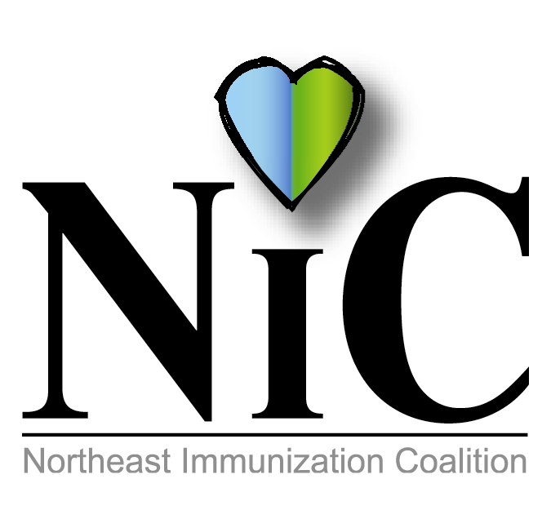

NIC MINUTES
April 5, 2019

The meeting was held at the WBCHD, Lackawanna State Health Center in Wilkes Barre at 10:30AM.
In attendance: Delphine Torbik, WBCHD; Nicole Amos WBCHD; Terry Metcalf, DOH; Chris Royek, DOH; Jane Osborn, DOH; Mike Lunney, Merck; Cindy Kern, Pfizer; Mary Fritz, Head Start; Jennifer Quinn, DOH; Julie Hargett-Watkins, DOH; Beth Boylan, Sanofi; and Mark Solomon, Sanofi.
Welcome and introductions were done.
REVIEW FEBRUARY MINUTES:
Minutes were reviewed and accepted.
FISCAL REPORT:
CEO Balance is $3111.52.
Wilkes Barre City Health Department had grant monies: $2355.82 until June 2019 to use. We purchased T-shirts and signs for the St. Patrick’s Day Parade costing $1367 which left us $988.82.
We also purchased pop sockets, costing $473 for Wilkes University Annual Health and Wellness Fair. This leaves us with 315.82 left to spend until 6-30-2019.

MEMBER UPDATES/COMMENTS:
Mike from Merck talked about the mumps and measles outbreak. Discussing a possible 3rd dose of MMR in the future.

Jennifer from Lackawanna SHC is still busy with Hepatitis A initiative. She was investigating a Hepatitis A case at a local restaurant.

Cindy discussed the Meningococcal B vaccine. More colleges are highly recommending the vaccine.
Also, PCV20 coming soon.

Mary from Headstart is trying to figure how to send home vaccine education information to families who do not immunize. Cindy will help her out by giving her some resources to check out.

Delphine informed the group of Devon resigning. Also, WBHD continues with the Hepatitis A initiative. Besides offering Hepatitis A vaccine at STD clinic, the health dept. went to Clem Mar. At risk group D&A. We are also collaborating with WYVAC and Caring Communities.

Mark from Sanofi stated they are closing in on flu reservations for next year. No delays or complications are expected at this point. Beth added that Adacel will be licensed for repeat vaccination (one time) 8 years after the first dose and for wound care being 5 years.

Terry also discussed the ongoing Measles outbreak.

BUS INITIATIVE:
Group discussed holding off on this project until August for National Immunization Awareness month.

NATIONAL INFANT IMMUNIZATION WEEK:
NIIW is April 27 to May 4. It is the 25th anniversary. The theme this year in Power to Protect. April 27, Bill will participate again in the YMCA Healthy Kids Day in Dunmore.

POST EVENT:
Nicole attended Boscov’s Health and Wellness Day Fair on March 28^{th.} She gave out antibacterial wipes and information on adult vaccines. WBHD participated at the Wilkes University Annual Health and Wellness Fair on April 2. Mumps fact sheets and information handed out on meningitis, MMR, and HPV. The pop sockets were ordered for this fair, but unfortunately they did not arrive in time. We gave out NIC stylus pens, phone card holders, and condoms. NIC members also participated in the St. Patrick’s Day Parade which was a huge success. Delphine passed around parade pictures and displayed the vinyl signs that were on the trailer.

UPCOMING EVENTS:
Wilkes-Barre Area Annual Wellness Fair at Kistler – April 5
PAIC, June 27 in Harrisburg
National Immunization Month – August
National Conference for Immunization Coalitions and Partnerships- Nov 13-15 in Honolulu

FUTURE PROJECTS:
PRIDE – NEPA Rainbow Alliance. This may be something we can do to promote immunizations. This event is very popular and brings a lot of people.
Mondays at the Market – Wilkes Barre City will continue their Mondays at the Market. It starts July 8 to August 19.

OTHER:
Delphine stated that Amy Wishner emailed a list of slide sets that are available online from the immunization Coalition which we can use for presentations such as Lunch and Learn at the local colleges. Will discuss in future meetings.

FUTURE MEETING DATES:
June 7, 2019
Aug 2, 2019
October 4, 2019
Dec 6, 2019.

Respectfully submitted,
Nicole Amos

