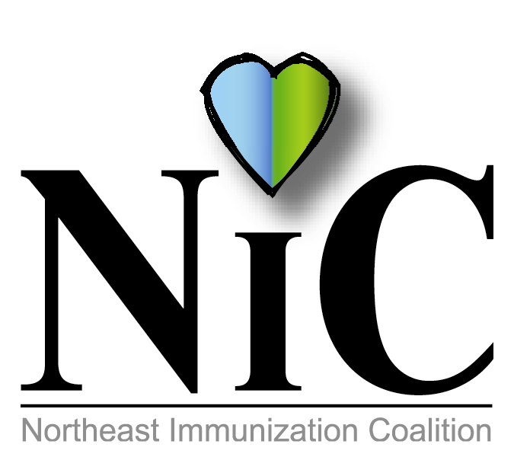10

NIC MINUTES
12-6-2019

The meeting was held at the Lackawanna State Health Center in Scranton.
In Attendance: Nicole Amos, WBHD; Kady Luchetti, WBHD; Jennifer Quinn, DOH; Jane Osborne, DOH; Amanda Moyer, DOH; Michael Lunney, Merck; Julie Hargett Watkins, DOH; and Mark Solomon, Sanofi.
Welcome and introductions were done.
REVIEW MINUTES:
Jane reported an issue with minutes from October. The minutes stated that there are no VFC providers in Wyoming County. She reported there are minimal providers.
FISCAL REPORT:
Balance from COE remains at $3111.52.
WBHD to add from grant $1039.91. We are awaiting invoices from Christmas Parade (stuffed animals and vinyl flu posters). Wilkes Barre City donated the candy.

MEMBER UPDATES/COMMENTS:

Kady updated group about the success of our Christmas Parade and thanked everyone who came out to help. She also noted that WBHD held a flu clinic on 12-2-2019 for National Influenza Week and a digital billboard advertising National Flu Immunization Week from November 25 to December 7. WBHD still continues with the Hep A initiative.

Mike discussed ACIP and adult vaccines with shared clinical decision making which limit offices to give vaccine without insurance verification. He also talked about the upcoming change about pneumonia vaccine not to be given routinely anymore at age 65.

Amanda reported her schools are finally caught up with required immunizations. She is also continuing with the Hep A Initiative.

Jennifer and Julie are continuing the Hep A initiative. They are partnering with Area of Aging on a new pilot program to help serve the aging population in Lackawanna County.

Mark informed the group about a change coming with the high dose influenza vaccine next season. It will be a quadrivalent vaccine with the dose increasing from .5 to .7ml. The safety profile is very similar to the trivalent vaccine on the market now according to research.

POST EVENT:
Wilkes-Barre Christmas Parade on Nov 23, 2019. Members of the NIC and some of their family members participated in this event. We distributed 400 stuffed animals with flu information along with candy.

National Influenza Week-December 1 thru Dec 7.

WEIS TUNKHANNOCK WYOMING COUNTY ADVERTISING OPPORTUNITY:
Weis Market has a shopping cart Adcart program that promotes different organizations and their services. Unfortunately, that program was filled. There is a new initiative that they will be starting. It is a freestanding hand sanitizer stand directly in the entranceway greeting weekly customers. Directly above the hand sanitizer a full color photo billboard with the organization and the message would be displayed. It is quite costly although it will be up for one year. A half board costs $1955 and a quarter board $1355. After discussion the group voted not to do this initiative due to the cost.

DIETRICH THEATRE:
Deferred until next meeting

UPCOMING EVENTS:
PAIC Conference June 18, 2020

FUTURE PROJECTS:
Educational Programs
? Lunch and Learn with local colleges
? Evening program with school nurses

FUTURE MEETING DATES:
Feb 7, 2020
April 3, 2020
June 5, 2020
Aug 7, 2020
Oct 9, 2020
Dec 4, 2020

Respectfully submitted,
Nicole Amos

