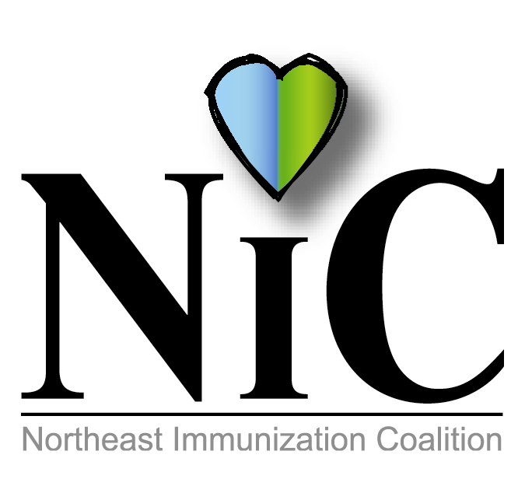

NIC MINUTES
February 1, 2019

The meeting was held at the WBCHD, Kirby Health Center, 71 N Franklin Street in Wilkes Barre at 10:30AM.
In attendance: Delphine Torbik, WBCHD; Joan Mueller, community; Jane Osborn, DOH; Mike Lunney, Merck; Jacob Daubert, Sanofi; Melissa Defina, Interactive Health; Donna Reilly, retired WBASD DON; Cathy Okrasinski, retired WBASD RN; Cindy Kern, Pfizer; Mary Fritz, Head Start; and Jennifer Quinn, DOH.
Welcome and introductions were done.
REVIEW DECEMBER MINUTES:
Minutes were reviewed and accepted.
FISCAL REPORT:
CEO Balance is $3111.52.
Wilkes Barre City Health Department grant monies: $2355.82.

MEMBER UPDATES/COMMENTS:
Cathy voiced concerns of measles on the rise and enforcement of mandatory vaccines in the schools. Discussion ensued.

Mike stated that Gardasil received FDA approval for ages extending to age 45. ACIP reviewed it and the CDC will vote in June.

Jennifer from Lackawanna SHC has been busy with Narcan distribution, diabetic clinic and the Hepatitis A initiative.

Cindy discussed the Meningococcal B vaccine. More colleges are highly recommending the vaccine. Kutztown and Bucknell require it.

Mary mentioned a vaccine for dental caries. This vaccine which has been under investigation for more than 30 years would prevent and protect against tooth decay. Streptococcus mutans has been identified as the major agent in tooth decay.

Delphine and Lois Elich from PA DOH presented an in service to the Office of Aging staff. There were approximately 40 in attendance. Along with information on certain communicable diseases, adult immunization was discussed. NIC antibacterial wipes were distributed to those in attendance.

BUS INITIATIVE:
Melissa stated that she did not receive a response from Colt Bus Company. She will follow up.

HEPATITIS A INITIATIVE:
The state along with county/municipal health departments are actively involved in providing outreach and education to at risk population and providers. Hepatitis A Fact sheets were given to those in attendance to distribute to their community partners.

WILKES UNIVERSITY ANNUAL HEALTH AND WELLNESS FAIR:
We will be participating in the yearly Wilkes Health and Wellness Fair. It will be on April 2 from 11-2. Approximately 300 students and faculty participate in this fair.

NATIONAL INFANT IMMUNIZATION WEEK:
NIIW is April 27 to May 4. Last year we participated in YMCA Healthy Kids Day in Wilkes-Barre and Dunmore. Discussion whether to attend this year again. Will discuss further at next meeting.

FACEBOOK:
Melissa started a Facebook page for the coalition.

OTHER:
Delphine suggested we participate in the Scranton or Wilkes Barre St. Patrick’s Day Parade. The Scranton parade is on Saturday, March 9 and Wilkes Barre is March 10. The city has a trailer that can be used but we will need a vehicle to pull it. Delphine will contact the fire department for their assistance. We need people to walk along side or ride in the trailer. Most importantly, we need our mascot! Melissa volunteered to wear the bear. Thank you to her. Everyone was in favor of this activity to promote immunizations.

FUTURE PROJECTS:
PRIDE – NEPA Rainbow Alliance. This may be something we can do to promote immunizations. This event is very popular and brings a lot of people.
Mondays at the Market – Wilkes Barre City will continue their Mondays at the Market. It starts July 8 to August 19.

UPCOMING EVENTS:
National Infant Immunization Week (April 27-May 4)
PAIC June 27, 2019 – Harrisburg
National Immunization Month – August 2019
National Conference for Immunization Coalitions and Partnerships - Nov 13 15

FUTURE MEETING DATES:
April 5, 2019 at Lackawanna County SHC
June 7, 2019
Aug 2, 2019
October 4, 2019
Dec 6, 2019.

Respectfully submitted,
Delphine Torbik

