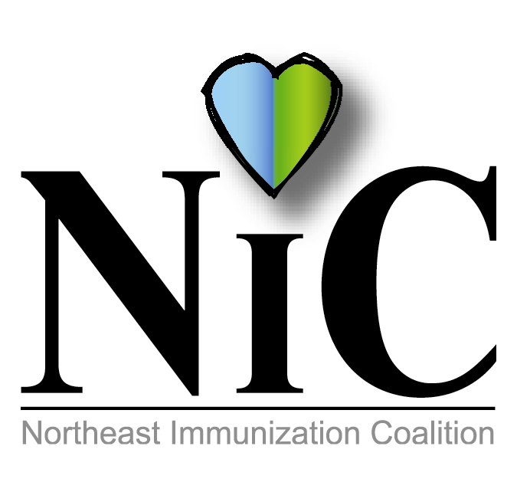10

NIC MINUTES
10-25-2019

The meeting was held at the WBCHD Kirby Health Center in Wilkes-Barre at 10:30A.M.
In Attendance: Delphine Torbik, WBHD; Nicole Amos, WBHD; Kady Luchetti, WBHD; Annie West, WBHD: Beth Boylan, Sanofi; Cathy Okrasinski, retired WB Area School Nurse; Jenni Marcho, GSK, Bill Court, PADOH ; Mary Jo DeMelfi; Kimberly Auman, Geisinger; Jennifer Quinn, DOH; Jane Osborne, DOH; Amanda Moyer, DOH; Mary Fritz, Head Start; Cindy Kern, Pfizer; and Joan Mueller, retired RN.
Welcome and introductions were done.
REVIEW MINUTES:
Minutes were reviewed. Delphine stated that discussion on the Bus Initiative was inadvertently omitted from the minutes. The bus initiative for Hazleton Public Transit cost is quite reasonable. We can do 20 buses for 12 months for $110.00 interior display. The overhead signs measure 11 X 28. Sign reads “Vaccines Save Lives-Did You Get Yours.” The cost will be in the Coraplast signs. Waiting for price from Wet Paint.
FISCAL REPORT:
Balance from COE remains at $3111.52.
WBHD to add from grant $1039.91. Monies to be used by June 30, 2020.

MEMBER UPDATES/COMMENTS:

Delphine updated group about the WBHD flu clinics and the ongoing Hepatitis A outbreak. She also spoke about our 1 confirmed vaping case death.

Mary from Head Start – Today is the deadline for children to have children have vaccines or be excluded from school. Mary happily reported that every child is up to date on vaccine and there will be no exclusions. 😊

Cindy discussed ACIP language changing on vaccines. Awaiting same to be published.

Beth reviewed ACIP recommendations. She gave a brief overview on Tdap schedule. Also, she stated that the restrictions for tubersol have been lifted.

Kim is involved with the Central Pennsylvania Immunization Coalition and she highlighted some initiatives they have done and are planning to do. The group discussed possibly doing an educational program in the future. Kim stated she will help getting this off the ground.

Jenny spoke about Hepatitis A.

Bill informed the group Terry is on leave until the end of November and that he will be covering her area. He also discussed shipping VFC flu. They will be shipped on how orders were received.

Amanda and Jane discussed some challenges they are facing. There are no VFC providers in Wyoming County and Susquehanna has no public transportation which is a problem for many. Discussion ensued.

POST EVENT:
WBHD administered flu shots at Farmers Market Active Aging Day on Sept 23. NIC flashlights were distributed. Approx 96 Seniors received flu shots and flu info.
Nicole and Delphine attended the Senior Expo at Wyoming Valley Mall on Oct 3. Cooler bags and eyeglass repair kits were distributed with info on adult immunizations. 300 bags were distributed.

CHRISTMAS PARADE:
Group decided to participate in the parade. We will promote vaccines particularly flu. We will purchase two more vinyl signs. Mark will again pull the trailer. Line up is at 2PM. Parade starts at 3:00. Volunteers needed to walk or ride on the trailer so please let Delphine know if you are able to do so.

PA POLIO SURVIVORS NETWORK:
Oct 24 was Polio Day. Delphine reviewed an e-mail from Shannon Fyalkowski, program assistant, PA Chapter, American Academy of Pediatrics and PAIC. Polio is very close to being eradicated. Afghanistan and Pakistan still has disease. They had 95 cases this year. At PAIC we met, Carol Ferguson, who is founder of the PA Polio Survivors Network. She is open to discuss polio.

UPCOMING EVENTS:
National Conference for Immunization Coalitions and Partnerships- Nov 13-15 in Honolulu.
National Influenza Vaccination Week is December 1-7. WBHD will have a flu clinic on Dec 2 from 9:30 to 12 and from 2-6. This will be the final scheduled flu clinic.

FUTURE PROJECTS:
Lunch and Learn-will discuss with Kings and Wilkes

OTHER:
Delphine received information from Community Showcase Banners. Wilkes Barre is adding banners to the city streets. The group looked over the banners but for the little amount that can be placed on the banner and the cost it was not worth it.

FUTURE MEETING DATES:
Dec 6, 2019 at Lackawanna SHC.

Respectfully submitted,
Nicole Amos

