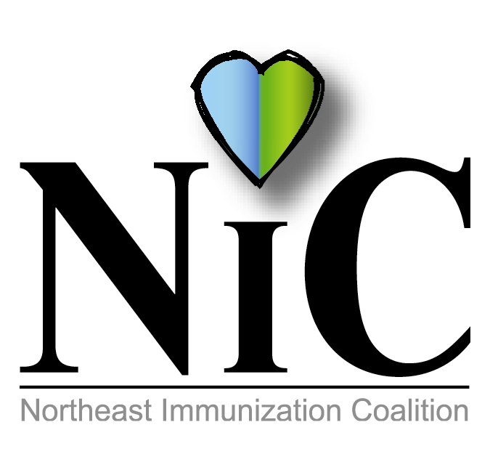

NIC MINUTES, 12-7-2018

The meeting was held at the WBCHD, Kirby Health Center, 71 N Franklin Street in Wilkes Barre at 10:30AM.
In attendance: Delphine Torbik, WBCHD; Nicole Amos, WBCHD; Devon Buckley, WBCHD; Joan Mueller, community; Eileen Attar, Surgical Specialty Care; Jane Osborn, DOH; Adria Laboy, Etna; Mike Lunney, Merck; Jenni Marcho, GSK; Jacob Daubert, Sanofi; Beth Boylan, Sanofi; and Melissa Defina, Interactive Health.
Welcome and introductions were done.
REVIEW SEPTEMBER MINUTES:
Minutes were reviewed and accepted.
FISCAL REPORT:
CEO Balance is $3111.52. From July 1, 2018 to June 30. 2019, we will have $2355.82 from WBCHD.

NATIONAL INFLUENZA VACCINATION WEEK:
Week of December 3 -7. WBCHD held an all-day flu clinic at the Kirby Health Center on Dec 6. Jacob from Sanofi stated that orders are 100% completed. It appears that more people are getting vaccinated. There are 5 pediatric deaths as to date.

BUS INITIATIVE:
Delphine gave overview on pricing for Hazleton bussing as discussed with the Hazleton Public Transit representative:
Shelter Ads which are located at the Laurel Mall, Walmart and Freeland would cost $100.00 for exterior, $75.00 interior or both for $160.00 for two-sided per month.
A queen size sign on the curb side of the bus would run $480.00. This sign is ideal for reaching those boarding the bus or pedestrians.
An interior display, inside the bus, would reach passengers for an average of 15 minutes per trip. Cost $5.25 per sign, per month. After discussion the group decided we would do interior display which would say “VACCINE SAVES LIVES, DID YOU GET YOURS.” Melissa stated we should do a different city in every county and will investigate pricing for the different counties. We will start this initiative early next year and discuss more at next meeting. More information to be obtained from Colts Bus Company in Scranton and Pocono Pony Transit in Monroe County.

HEPATITIS A
Due to the recent increase of Hepatitis A this year in PA (80% increase of disease), a press release was released to heighten surveillance by PA DOH. There have been outbreaks in Ohio and West Virginia. DOH is encouraging Hep A vaccination to certain at-risk groups such as homeless, IV drug users, and MSM. Harrisburg spoke with CDC regarding grant opportunities for funding Hep A vaccination. The group talked about doing a Hep A initiative focusing on education. Will be further discussed at the next meeting.

UPCOMING EVENTS:
National Infant Immunization Week (April 26 – May 3, 2019)
PAIC (June 27, 2019) at the Hilton in Harrisburg.
National Immunization Month – August 2019
National Conference for Immunizations Coalitions and Partnerships (Nov 13-15, 2019) in Honolulu.

SURVEY RESULTS:
Sadly, no one member filled out survey ☹. Delphine briefly went over questions. We decided to keep the same day and time. We will try to alternate sites in different counites. We will update as to when we will be at a different site.

NIC OFFICERS:
Please consider becoming a NIC officer. Delphine and Nicole have been in the same positions for a long time, please consider these positions. Thank you in advance for your consideration.

FUTURE MEETING DATES:
February 1, 2019
April 5, 2019
June 7, 2109
August 2, 2019
October 4, 2019
December 6, 2019.

Meetings will take place at Kirby Health Center, 71 N Franklin St. Wilkes-Barre, PA 18701 unless otherwise stated.

OUR WEBSITE: https://www.immunizepa.org/northeast-immunization-coalition/

Respectfully submitted,
Nicole Amos

