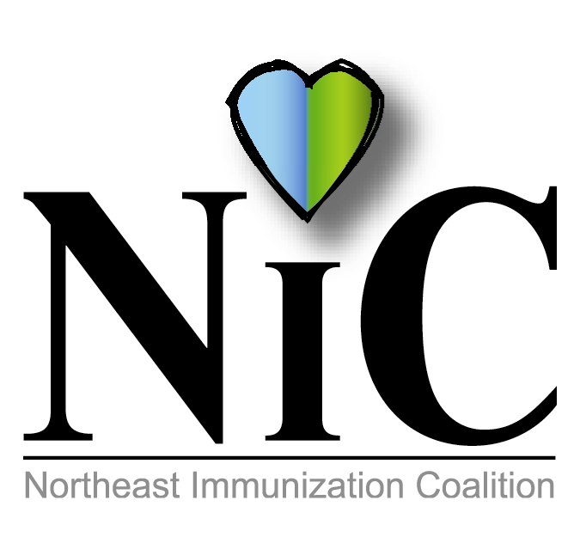

NIC MINUTES
June 7, 2019

The meeting was held at the WBCHD Kirby Health Center in Wilkes-Barre at 10:30A.M.
In Attendance: Delphine Torbik, WBHD; Nicole Amos, WBHD; Beth Boylan, Sanofi; Erica Bozentka, MFHS; Donna Reilly, retired WB Area DON; Mike Lunney, Merck; and Jenni Marcho, GSK.
Welcome and introductions were done.
REVIEW APRIL MINUTES:
Minutes were reviewed and accepted.
FISCAL REPORT:

Delphine reported on expenditures for events
$1376.00 for immunization signs and T-shirts for St. Patrick’s Day Parade
$501.38 Pop Sockets
$171.72 Lip Balm
$392.20 Lined Notebooks

MEMBER UPDATES/COMMENTS:
Erica stated a major change coming in October. MFHS will begin using EBT cards.

Mike gave a brief talk about MMR and stated HPV age will increase to 45 yrs old.

BUS INITIATIVE:
Group decided back in December to do this bus initiative. It will be done in Hazleton. Will go with interior display stating “Vaccines Saves Lives, Did You Get Yours” for National Immunization month in August.

POST EVENT:

Wilkes Barre Area Annual Wellness Fair at Kistler Elementary School on April 5. NIC coloring books, crayons and notebooks with vaccine information given to students and parents.
Caring Communities(at-risk MSM) Hepatitis A Initiative-April 30 Only two clients received vaccine at the clinic but information was given to the others who refused.
Luzerne Day Reporting Center (at-risk D&A) on May 2 and May 9. This was a successful event. 29 Hepatitis A vaccine given.

UPCOMING EVENTS:
PAIC (June 27, 2019) Harrisburg Delphine, Terrry and Bill will be attending.
National Immunization Month – August
National Conference for Immunization Coalitions and Partnerships- Nov 13-15 in Honolulu

FUTURE PROJECTS:
PRIDE – NEPA Rainbow Alliance. This may be something we can do to promote immunizations. This event is very popular and brings a lot of people.

Mondays at the Market – Wilkes Barre City will continue their Mondays at the Market. It starts July 8 to August 19.

FUTURE MEETING DATES:
Aug 2, 2019
October 4, 2019
Dec 6, 2019.

Respectfully submitted,
Nicole Amos

