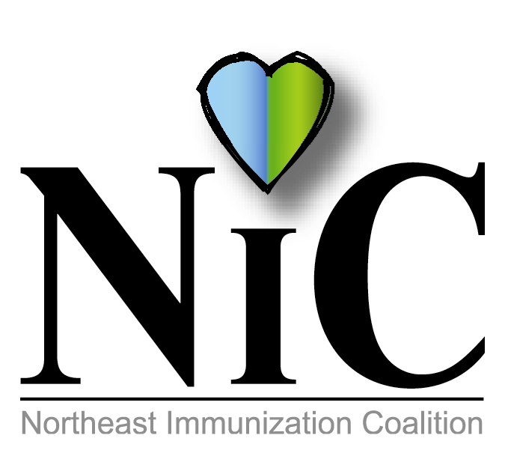

NIC MINUTES, 9-7-2018

The meeting was held at the WBCHD, Kirby Health Center, 71 N Franklin Street in Wilkes Barre.
In attendance: Delphine Torbik, WBCHD; Nicole Amos, WBCHD; Donna Reilly, retired school nurse from Wilkes Barre School District; Cathy Okrashinski, WBASD; Terry Metcalf, DOH; Joan Mueller, community; Mark Solomon, Sanofi; Eileen Attar, Surgical Specialty Care; Jane Osborn, DOH; and Adria Laboy, Etna; Beth Boylan, Sanofi Pasteur; Kimberly Auman, Geisinger; Melissa DeFina, Interactive Health; Michael Lunney, Merck; Erika Bozentka, Maternal Family Health.
Welcome and introductions were done.
REVIEW MAY MINUTES:
Minutes were reviewed and accepted.
MEMBER UPDATES
New member to NIC, Devon Buckley, Nancy Bellas, and Beth Boylan. Each member provided an update on their organization.
FISCAL REPORT:
CEO Balance is $3111.52. Monies all spent from WBCHD. We received extra money that we needed to spend by June 30. We purchased canister wipes with key chains ($346.56) and Silicone Tech Pockets ($547.84) to distribute at NIC events. A purchase was made for an advertisement in Susquehanna County Independent and Weekender for 6 weeks which cost $423.60. From July 1, 2018 to June 30, 2019 we get 2355.82 from the WBCHD. The key chains and tech pockets were on display and available to members to distribute.

48th NATIONAL IMMUNIZATION CONFERENCE
This event brings together 1500 local, state, federal and private immunization stakeholders together. Theme this year is “Prevention, Protection and Progress”. This conference was held May 15-17 in Atlanta. Delphine, Stephanie, Kim and Beth attended.
Delphine highlighted some points of interest that were presented at the conference:
Ways to increase vaccine awareness via social media…you tube etc.…
When doing a presentation make it personal? Personal stories seem to make a bigger impact on the audience. Be explicit not complex.
A presentation was done on micro-needling that will be coming in a few years. It is a new way to administer vaccines without the use of needles. Currently in clinical trials.

2018 ANNUAL PAIC MEETING AND 24th PAIC CONFERENCE
The coalition meeting was held Aug 15, 2018. Each coalition gave an update on their projects, successes and challenges. Challenges seemed to be the same for all coalitions; money and membership. A common goal is to have educational dinners with CEU’s.
The conference was held Aug 16. The theme “No Matter the Size Immunize.” Personal stories were given by individuals who were affected with pertussis, Hepatitis B and polio. CDC updates were presented along with pediatric immunization updates.

NATIONAL IMMUNIZATION AWARENESS MONTH ACTIVITIES-AUGUST 2018
Thank you to Jane Osborn for spearheading an adult initiative in Susquehanna County. For 6 weeks an advertisement was placed in the Susquehanna County Independent and Weekender promoting adult vaccines. The advertisement was placed in various places within the paper. A copy of the papers was passed around.

Letter to Camp Administrators-113 letters were sent to summer camps in our counties promoting vaccines that campers should have before attending camp. Letter was shared with those in attendance.

Mondays at the Market-This market was sponsored by the Wilkes Barre City Health Department each week from July 2 to August 27. This market promoted healthy eating and living habits. Numerous organizations attended each week including NIC in collaboration with the health department. Immunizations for all ages were promoted each week. Each week from 100 to 300 pamphlets and items were distributed.

BROCHURE:
Our NIC brochure was reviewed. Some new organizations were added. The address will be changed to 71 North Franklin St, Wilkes Barre, Pa 18702 because the Northeast District Office will be moving soon. Also discussed possibility of getting the brochures done professionally but was decided to make copies. More cost effective.

SURVEY:
A survey will be e-mailed to all members concerning their thoughts on the coalition meetings. Please complete and return before the next meeting.

HEALTH CHOICES MEETING:
Adria passed out information on an informative meeting that will be held this month.

NIC 15 Years Strong…Past, Present and Future
Congratulations to NIC…15 years promoting vaccines. The first meeting was August 23, 2003. Nicole, Terry, Beth and Donna have been with the coalition from the very beginning. A cake was enjoyed by all.
Some past projects: Little league signs; 5KRun; St. Patrick’s Day Parade; Health Fairs; Movie Theater PSA; Luggage Tags; Price chopper pharmacy bags; Drive in PSA slide; U Don’t Get it campaign; HPV mugs; Dietrich Theater, someone you love; Digital Billboards; Penguins Booth.
Future Projects: Bus project in Hazleton; Christmas Parade, Nov 27,2018; Vote and Vax; Educational programs with CEUs.

NIC OFFICERS:
A co-chair is NEEDED!

MINI-GRANT OPPURTUNITY:
Samantha Pierpoint sent an email concerning a PA Oral Health Plan mini grant opportunity. This grant concerns HPV vaccination and oropharyngeal cancer with dentists. Deadline 9-28-2018. Discussion ensued.

NEXT MEETING LOCATION AND TIME:
Nov 2, 2018

Meetings will take place at Kirby Health Center, 71 N Franklin St. Wilkes-Barre, PA 18701.

OUR WEBSITE: https://www.immunizepa.org/northeast-immunization-coalition/

Respectfully submitted,
Nicole Amos

