Vaccine-Preventable Diseases (VPDs): How Can You Do More to Help Protect Your Patients?
VPDs can lead to a serious clinical burden for health care providers, patients, and the community at large. As a health care provider, you play a vital role in educating your adult patients on vaccine- preventable diseases and advocating the importance of receiving adult vaccinations recommended by the Centers for Disease Control and Prevention (CDC).1
Your recommendation is a key factor in determining if your older adult patients receive appropriate vaccinations.2 Knowing the potential implications of VPDs can help.

Potential Implications of Common VPDs3-7

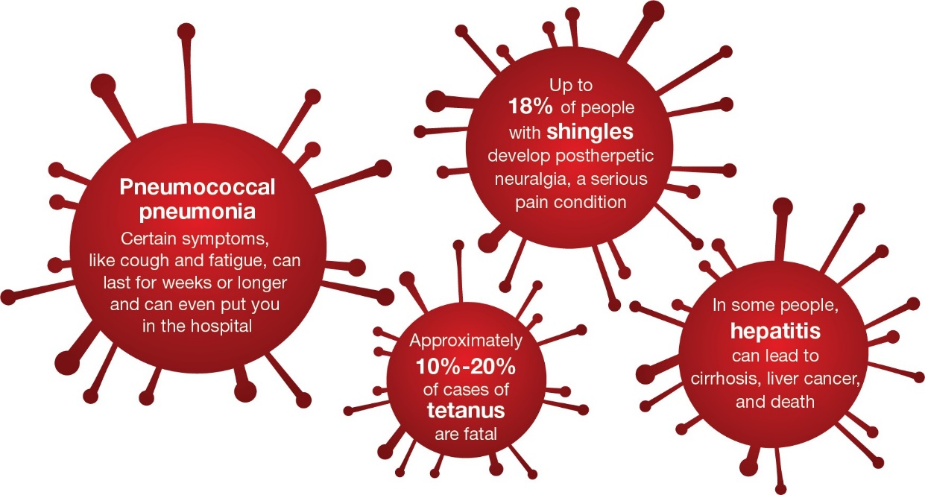
Pneumococcal pneumonia can lead to serious clinical consequences for older adult patients. Adults 65 or older are over 10 times more likely to be hospitalized with pneumococcal pneumonia than adults 18-49.8,9
There are certain steps you can take to help protect your older adult patients against serious diseases, like pneumococcal pneumonia.
- Assess your older adult patients at every clinical opportunity to determine if they are appropriate for CDC-recommended vaccinations
- Discuss risks for disease and vaccinations available to help protect against VPDs
- Offer and administer adult vaccinations to your appropriate patients according to CDC recommendations

Speak with your older adult patients about the risk for VPDs and the importance of vaccination
1. Centers for Disease Control and Prevention (CDC). Standards for Adult Immunization Practice.
https://www.cdc.gov/vaccines/hcp/adults/for-practice/standards/index.html. May 2, 2016. Accessed August 3, 2020. 2. Winston CA, Wortley PM, Lees KA. Factors associated with vaccination of Medicare beneficiaries in five US communities: results from the racial and ethnic adult disparities in immunization initiative survey, 2003. J Am Geriatr Soc. 2006;54(2):303-310. 3. el Moussaoui R, Opmeer BC, de Borgie C, et al. Long-term symptom recovery and health-related quality of life in patients with mild-to-moderate community-acquired pneumonia. Chest. 2006;130:1165-1172. 4. Jain S, Self WH, Wunderink RG, et al, for the CDC EPIC Study Team. Community-acquired pneumonia requiring hospitalization among US adults. N Engl J Med. 2015;373(5):415-
427. 5. CDC. Shingles burden and trends. https://www.cdc.gov/shingles/surveillance.html. Updated August 14, 2019. Accessed August 3, 2020.
6. National Foundation for Infectious Diseases (NFID). Tetanus questions and answers. https://immunize.org/catg.d/p4220.pdf. June 2020. Accessed August 3, 2020. 7. World Health Organization. Hepatitis B. https://www.who.int/news-room/fact-sheets/detail/hepatitis-b. July 27, 2020. Accessed August 3, 2020. 8. Ramirez JA, Wiemken TL, Peyrani P, et al. Adults hospitalized with pneumonia in the United States: incidence, epidemiology, and mortality. Clin Infect Dis. 2017;65(11):1806-1812. 9. Data on file. Pfizer Inc, New York, NY.

PP-PNA-USA-4378-02 © 2020 Pfizer Inc. All rights reserved. October 2020

