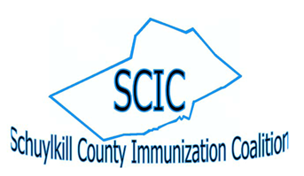

SCIC Zoom Meeting Minutes – 10/8/2021

Attendees: Marianne Adam (PSU – Schuylkill) mta133@psu.edu
Mandy Fitzpatrick (Schuylkill County VISION) mfitzpatrick@schuylkillvision.com
Kayla Knock (PA AAP, PAIC) kknock@paaap.org
Stephanie Mihailescu (PA Chapter AAP, PAIC) Smihailescu@paaap.org
Jenny Wagner (Diakon Community Services) wagnerje@diakon.org
Alyssa DeFazio (Penn State Extension) aad180@psu.edu

Welcome/Introductions

Schuylkill County Emergency Management Agency (SCEMA)
- COVID vaccination statistics for Schuylkill County residents, shown by number and percentages vaccinated by age group, can be found at scema.org

PAIC Funding Opportunity – Kayla/Mandy
- Funding Opportunity: Promoting COVID-19 Vaccine Education and Outreach for Pennsylvania’s
Under-Vaccinated Communities
- Schuylkill County Immunization Coalition (SCIC) applied for funding; PAIC to be fiscal manager
(for Schuylkill, Chester and Berks counties) and to oversee staff person at their office in Media
who will be covering these counties; local grant staff also written into SCIC application
- PA AAP will meet on Tuesday to confirm grant recipients and Kayla will notify coalition heads

PAIC Updates – Stephanie Mihailescu
- Statewide Vaccine Promotion Ad Campaign taking place
- Local paper to be used is the Pottsville Republican Herald

Flu Shot Drive Thru and Walk In Clinics – Jenny
- Local health care organizations are offering drive-thru and walk in vaccination clinics
- Geisinger St. Luke’s (geisinger.org/flunews); LVHN (please see attached flyer)
- PA Department of Health has a Vaccination Clinic Partnership Form that can be used to match vaccine providers with community based organizations to offer vaccination clinics (https://form.jotform.com/211333640273042/)

Penn State Extension EXCITE Program – Alyssa DeFazio
- Based off REACH Project
- 2-year grant; just started
- Survey was conducted to establish baseline data
- To provide education about COVID and other vaccines (COVID, flu, shingles) and to address vaccination hesitancy
- Part I: Latinx
- Part II: Latinx & farm workers
- Meet bi-weekly; Alyssa is team member of grant

Next Meeting
- December 10, 2021 at 8:30 am

