There are things you can do, like exercising, eating right, and getting enough sleep, to help protect yourself against potentially serious diseases. Another step you can take to help protect against potential sickness from vaccine-preventable diseases (VPDs) is to get vaccinated!

What You Should Know About Some Common VPDs Affecting Adults1-5

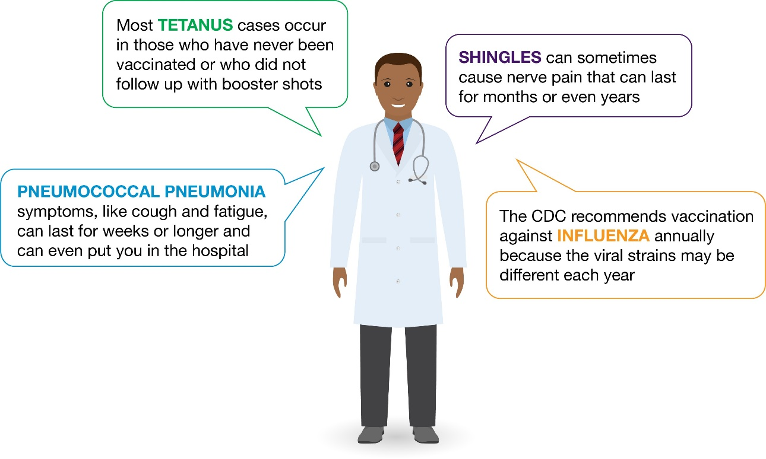

Pneumococcal (noo-muh-KOK-uhl) pneumonia, a potentially serious infection of the lungs, may be less familiar to you than some of the other diseases above. Adults 65 or older are over 10 times more likely to be hospitalized with pneumococcal pneumonia than adults 18-49.6,7

Did You Know?
- The symptoms of pneumococcal pneumonia can come on quickly and may include8
  - High fever and shaking chills
  - Chest pain with difficulty breathing
  - Cough with phlegm that persists or gets worse

Talk with your doctor about the risks for potentially serious VPDs, like pneumococcal pneumonia, and about the importance of adult vaccinations

References: 1. National Foundation for Infectious Diseases (NFID). Shingles (herpes zoster). https://www.nfid.org/infectious-diseases/shingles. Accessed August 3, 2020. 2. Centers for Disease Control and Prevention (CDC). Key facts about seasonal flu vaccine. https://www.cdc.gov/flu/prevent/keyfacts.htm. April 28, 2020. Accessed August 3, 2020. 3. el Moussaoui R, Opmeer BC, de Borgie C, et al. Long-term symptom recovery and health-related quality of life in patients with mild-to-moderate community-acquired pneumonia. Chest. 2006;130:1165-1172. 4. Jain S, Self WH, Wunderink RG, et al, for the CDC EPIC Study Team. Community-acquired pneumonia requiring hospitalization among US adults. N Engl J Med. 2015;373(5):415-427. 5. NFID. Tetanus questions and answers. https://immunize.org/catg.d/p4220.pdf. June 2020. Accessed August 3, 2020. 6. Ramirez JA, Wiemken TL, Peyrani P, et al. Adults hospitalized with pneumonia in the United States: incidence, epidemiology, and mortality. Clin Infect Dis. 2017;65(11):1806-1812. 7. Data on file. Pfizer Inc, New York, NY. 8. CDC. Pneumococcal disease. In: Hamborsky J, Kroger A, Wolfe S, eds. Epidemiology and Prevention of Vaccine-Preventable Diseases. 13th ed. Washington, DC: Public Health Foundation; 2015:278-296.

PP-PNA-USA-4378-04 © 2020 Pfizer Inc. All rights reserved. October 2020

